Dronfield Henry Fanshawe School
OCR A Level Design & Technology: Design Engineering & Product Design
Project for September
A successful designer or engineer will be inquisitive and inventive to help them plan, design, analyse and build their creations and prototypes. The engineer needs to understand the materials and processes they will work with and the constraints that are put on them.

Design Brief
University students are often limited with their workspace in their accommodation. You are to design and engineer an adjustable light to be used in a variety of locations.

Product specification
An designer or engineer must make sure products meet the product specification. This will ensure quality of design and that the end product is fit for purpose.
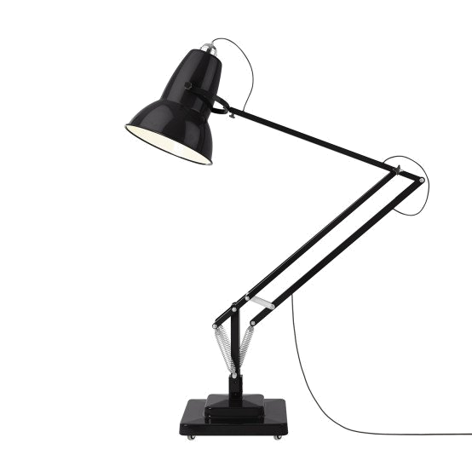
- The light must be stable, when adjusted in any possible lighting position.
- The light must be adjustable in height as well as the direction of the light
- The light must stand no taller than 250mm

What should my project include?

- Research analysis on existing adjustable lamps. What is available? How do they function? What mechanisms do they use? What materials are they made from?
- One A3 page of design ideas – quick sketches - minimum of 10 fully annotated.
- Use card modelling to test out and evaluate your chosen idea with all developments explained
- A scale card model of your final prototype
- Deadline to be handed in on your first lesson of BTEC level 3 engineering in September

