A level English Literature

Transition Pack

Welcome!

Welcome to A Level English Literature. The step up from GCSEs to A Levels can seem daunting but don't panic, this transition pack is designed to help you prepare for the course that you are interested in taking in September.

The pack includes an overview of what you will study during the course together with a series of introductory tasks for you to work through. The tasks are designed to help you get to grips with some of the key terms you will need to know, as well as concepts you will learn about as a student of English Literature. There are also lots of opportunities for wider reading and getting to grips with the genres your course will be based around.

In English Literature you have the opportunity to explore both tragedy and crime texts considering their generic conventions and how they fit into the wider genre. You will engage with debates surrounding texts, characters and the genres themselves which will help to develop your criticality and analytical voice. Towards the end of Year 12, you will also complete coursework and do critical readings of a prose and poetry text.

The course requires students who love reading and literature. Students need to be critical thinkers, developing their own opinions and interpretations of texts. Students should also have good organisation skills and be willing to carry out independent study tasks to enrich the learning which happens in lessons. English Literature is a subject which allows you to understand the human condition, explore and learn about our past, present and how to approach the future. It is also a facilitating subject which provides diverse opportunities for further study and your future careers.

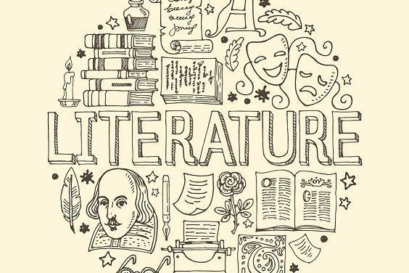

Texts you will study

In your first term you will start by studying some of Keats’ poetry and William Shakespeare’s Othello therefore engaging with both a poetic work and Shakespearean tragedy. Both are rich texts which follow the tragic hero towards their downfall as they interact with an array of engaging characters and find themselves wrapped up in some familiar situations. With your other teacher you will start with an introduction to crime fiction, then read an Agatha Christie classic: The Murder of Roger Ackroyd.

You will continue to focus on the world of crime fiction with study of Coleridge’s famous poem The Rime of the Ancient Mariner, unseen crime extracts and Kate Atkinson’s When Will There Be Good News?. And for your tragedy paper, you will study more of Keats’ poetry, and then Arthur Miller’s 20th century drama: Death of a Salesman. During this time, you will really get to grips with key tragedy and crime conventions and the big questions which surround the genres

As previously mentioned, there is also a coursework element (the NEA) to the A Level English Literature course. During Year 12 you will study the critical theories which will allow you to do an theoretical reading of a poetry and prose text of your choice.

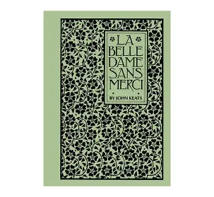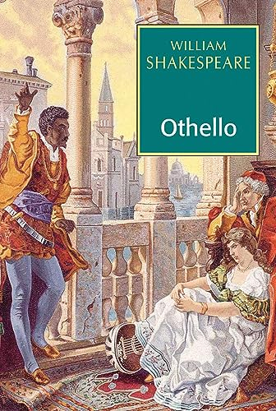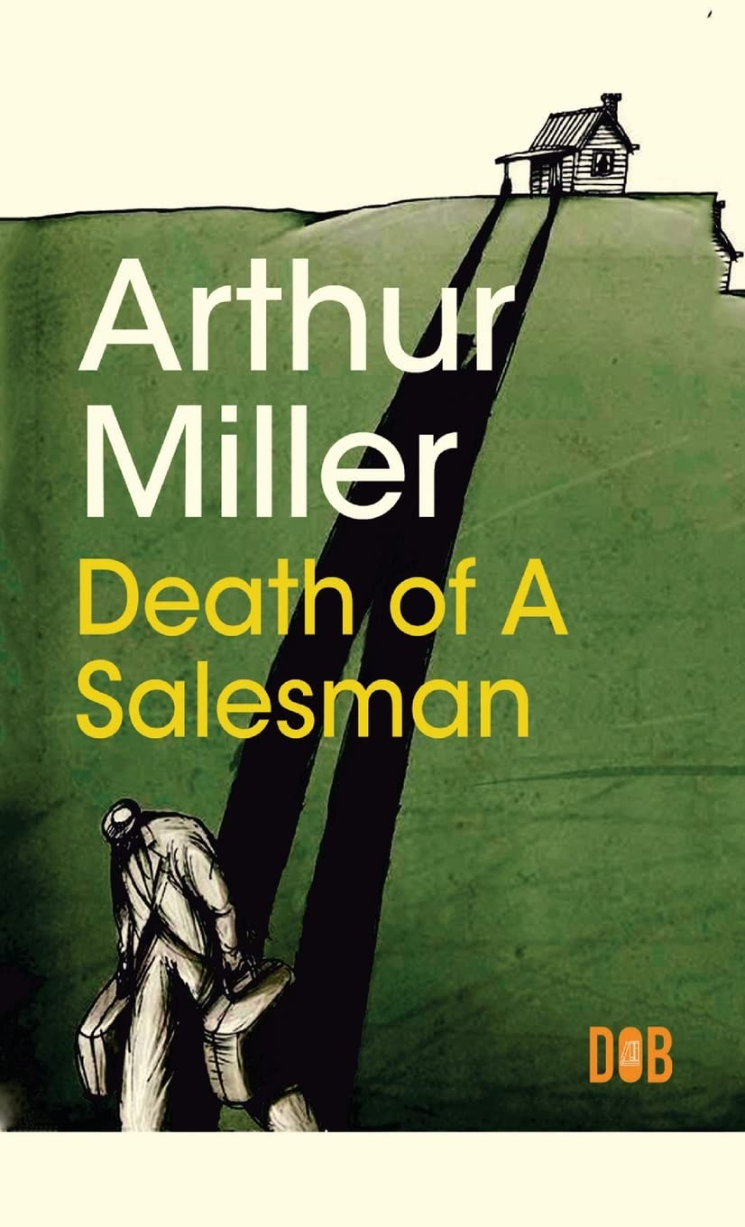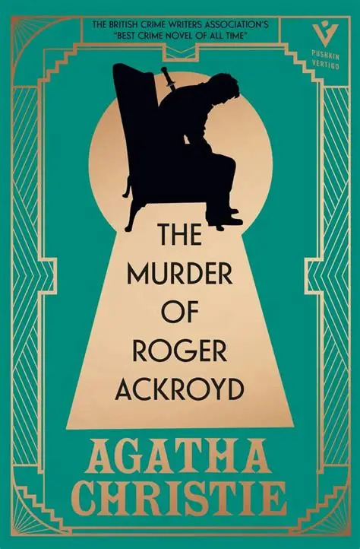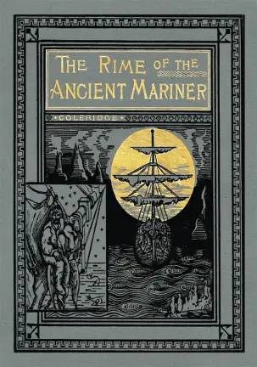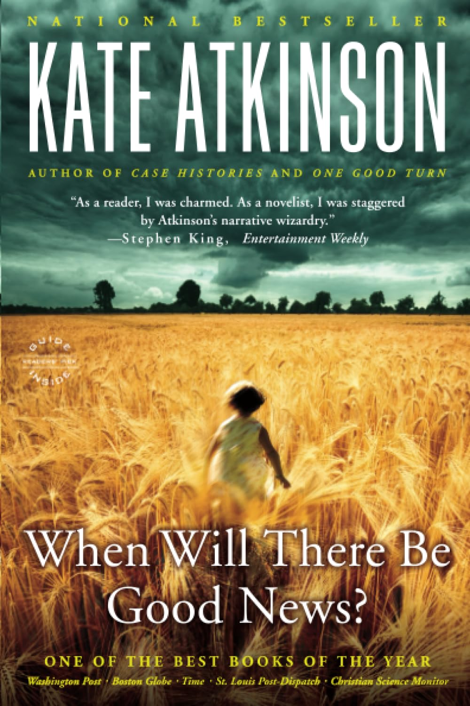

English Literature Preparatory Tasks

Please complete each of the compulsory tasks set out in this transition pack (and any optional extras) and bring your work with you to the first lesson in September if you join the course.

Task 1: Tragedy and Crime (compulsory)

Tragedy and crime are huge ideas, and both can be things which are experienced in real life. These big ideas are central to your study of English Literature. To start off let’s engage with these ideas and what they mean to you now.

Think about news stories or things that have happened in the world recently that are considered tragedies. What happened? How is this tragic? How do newspapers and the media present tragedy?

Think about high-profile crimes that have happened. What happened? What makes it a crime? How do newspapers and the media present crime?

Try to come up with your own definitions of tragedy and crime and be ready to share and discuss your ideas in lessons!

Task 2: Glossary (compulsory)

As with all subjects, English Literature will introduce you to lots of key terms, many of which are likely to be new to you. In the table below some of these key terms are listed. Find definitions of each of the terms. There is space at the bottom for any others you find. The glossary you create can be a reference document to be used later, so make sure it is well presented and clearly set out.

ALLEGORY
ANTAGONIST
ANTHROPOMORPHIC
ANTI-HERO
ARCHAIC
ASPECTS
ASIDE
ATYPICAL
AUTODIEGETIC NARRATOR
BALLAD
BATHOS
BLANK VERSE
CATHARSIS
CONTEXT
CONVENTIONS
DEBATE
DECLARATIVE
DENOUEMENT
IAMBIC PENTAMETER
IDEOLOGY
IMPERATIVE
INRADIEGETIC
INTERROGATIVE
METAPHOR
HUBRIS
HAMARTIA
FATE
FOCALISED NARRATIVE
FREE INDIRECT SPEECH
GENRE
SOLILOQUY
SYMBOLISM
TYPICAL
DRAMATIC MONOLOGUE
ELEMENTS
ENJAMBMENT
EXCLAMATORY
PRONOUN
PROSE
PROTAGONIST
SEMIOTICS
SIGNIFICANCE
STICHMOYTHIA
PATHOS
PERSONIFICATION
METRE
MOTIFS
NARRATIVE
OMNISCIENT

Extra reading (compulsory)

Task: Read at least one book for pleasure over the summer

In English Literature, alongside your two exams, you will also complete coursework. You will complete one piece of coursework on a prose text and one on a poetry text. You will choose both texts yourself towards the end of Year 12.

Below is a list of recommended reading for each of the critical theories in the critical anthology you will be studying alongside your choice of text. Although not an exhaustive list, these are some suggested novels which you may enjoy, and may give you some options in summer.

You cannot study the following (as they are on the specification): Tess of the D’urbervilles, Emma, Small Island, When Will There be Good News?, The Murder of Roger Ackroyd, Oliver Twist, The Handmaid’s Tale, Harvest, Hard Times, The Kite Runner, Atonement, Brighton Rock (and others!). Do check with your teachers in September.

Ideas about narrative
Jane Austen – Pride and Prejudice
Sebastian Barry – The Secret Scripture
J.L.Carr – A Month in the Country
Charles Dickens – Great Expectations
Sebastian Faulks – Birdsong
Cormac McCarthy – The Road
Ian McEwan – A Child in Time
Ian McEwan – Enduring Love
David Nicholls – One Day
Arundhati Roy – The God of Small Things

Marxist ways of reading
Sebastian Barry – The Secret Scripture
Thomas Hardy - The Mayor of Casterbridge
L.P.Hartley – The Go-Between
Aldous Huxley – Brave New World
Milan Kundera – The Unbearable Lightness of Being
George Orwell – 1984
Chuck Palahnuik – Fight Club
J.D Salinger – The Catcher in the Rye
John Steinbeck – The Grapes of Wrath
Mark Twain – Huckleberry Finn
Anne Tyler – Digging to America

Feminist ways of reading
Margaret Atwood – The Edible Woman
Angela Carter – The Bloody Chamber
Khaled Hosseini – A Thousand Splendid Suns
Sue Monk Kidd – The Secret Life of Bees
D.H.Lawrence – Sons and Lovers
Sylvia Plath – The Bell Jar
Bram Stoker – Dracula
Alice Walker – The Colour Purple
Virginia Woolf – Mrs Dalloway

Post-colonial ways of reading
Chinua Achebe – Things Fall Apart
Chimanda Ngozi Adichie – Americanah
Aravind Adiga – Last Man in Tower
Monica Ali – Brick Lane
Jane Austen – Mansfield Park
Joyce Carey – Mister Johnson
Joseph Conrad – Heart of Darkness
Daniel Defoe – Robinson Crusoe
Ralph Ellison – Invisible Man
E.M. Forster – A Passage to India
Mohsin Hamid – The Reluctant Fundamentalist
Jhumpa Lahiri – Interpreter of Maladies (short stories)
Jhumpa Lahiri – The Lowland
Toni Morrison – Beloved
Jean Rhys – Wide Sargasso Sea
NoViolet Bulawayo – We Need New Names
Salman Rushdie – Midnight’s Children
Paul Scott – Staying On
Taiye Selasi – Ghana Must Go
Zadie Smith – White Teeth
William Trevor – Fools of Fortune

Task 4: Tragedy tasks (optional)

English Literature requires you to be able to apply the aspects of tragedy to texts which you study and explore how they exist within the genre. The following tasks will allow you to research some of these key aspects and begin trying to apply them to different types of texts.

Task 1:
Find out some information on Shakespearean tragedies. You will need to research the following:
-The tragic hero
-The tragic/fatal flaw
-The five-part tragic structure
-Conflict-external and internal
-Elements of the abnormal/supernatural/fate/fortune and chance

Task 2:

Choose one of Shakespeare's tragedies from the list below (be sure to avoid King Lear) and do research which allows you to apply the elements of Shakespearean tragedy to the play.

Who is the tragic hero?
What tragic flaws do they possess and how are they shown to the audience?
What events occur to fulfil the five-part tragic structure?
How does the tragic hero experience external and internal conflict?
Where are their elements of the abnormal/supernatural/fate/fortune and chance?

You can present your ideas as notes or a mindmap.

Shakespeare’s tragedies:
- Antony and Cleopatra
- Coriolanus
- Hamlet
- Julius Caesar
- Macbeth
- King Lear
- Romeo and Juliet
- Timon of Athens

Task 5: Crime tasks (optional)

English Literature also requires you to be able to explore the elements of crime writing present in texts which you study and explore how these texts exist within the genre of crime writing. The following tasks will allow you to research different types of crime writing and some of the key elements of crime.

Task 1:

Research different types of crime fiction and key elements of crime writing. What different types can you find? What kind of writers would you associate with each type?

You can present your research as notes, a mindmap or timeline.
To further broaden your appreciation of the genre of crime writing you may also wish to complete some wider reading. Below is a reading list which offers a range of crime texts that span different time periods, cultures and themes.

These texts are not compulsory, but you may find them helpful in widening your understanding of the genre of crime.

John Buchan – The Thirty-Nine Steps
Raymond Chandler – The Big Sleep
Agatha Christie – Murder on the Orient Express etc.
Charles Dickens – Oliver Twist
Sir Arthur Conan Doyle – Sherlock Holmes stories
Daphne Du Maurier – Rebecca
Ian Fleming – Casino Royale, James Bond novels
Gillian Flynn – Gone Girl/Sharp Objects/Dark Places
Graham Greene – Brighton Rock
John Grisham – The Client, The Firm, The Street Lawyer, The Runaway Jury
Mark Haddon – The Curious Incident of the Dog in the Night-Time
Thomas Harris – Red Dragon, The Silence of the Lambs, etc.
Ian McEwan – Atonement

Further resources (optional)

Exploring events and opportunities linked to your study of English Literature can also be beneficial so look out for free online courses, performances, possible talks or events happening nearby.
Shakespeare plays are increasingly being screened at cinemas nationwide and although screenings may not be of a text you study, there could be great benefit from watching Shakespeare’s other tragedies. Engaging in discussion online can also be a way to further extend your ideas and engagement with the texts you study.

Useful websites:
https://www.rsc.org.uk https://www.futurelearn.com/courses/categories

Thank you for working through the tasks in this transition pack. Doing so will undoubtedly help you make a good start to the A Level English Literature course.

Please bring any work you complete to your first English Literature lesson. We look forward to seeing you in September and exploring brilliant texts with you.

