A Level English Language Summer work

English Language A Level
Summer 2026
Some of the topics we discuss during the course are:
- language and gender
- language and age
- language and region (accent and dialect)
- language and diversity
- language and identity
- child language development
- language change
- World Englishes

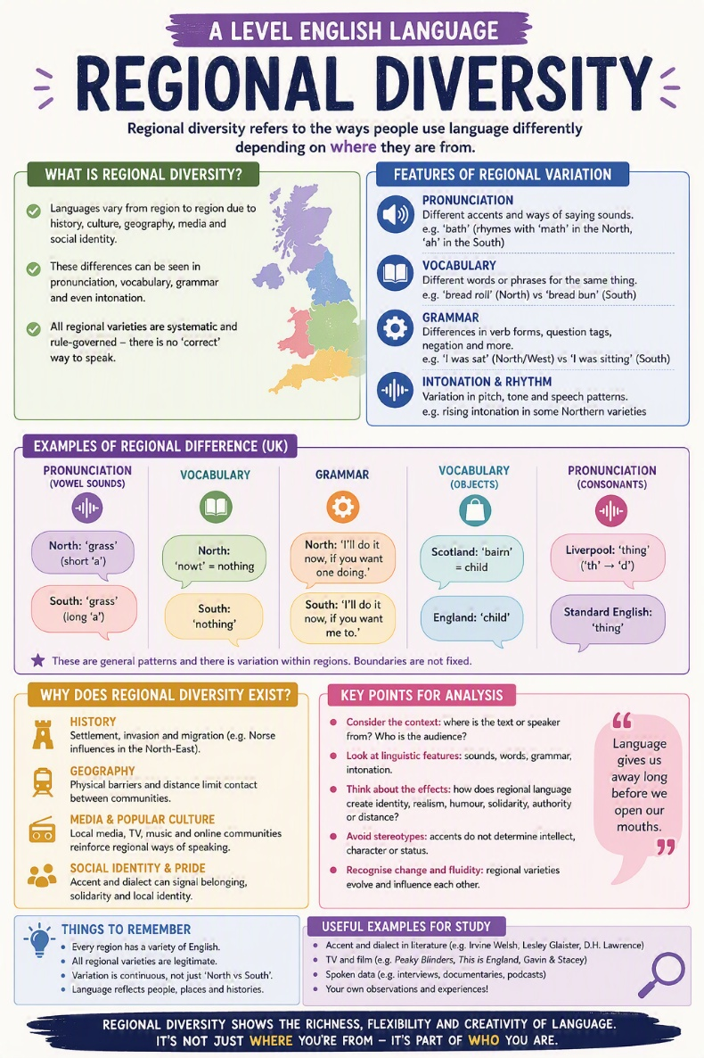
The following tasks are designed as a project to help you to start exploring some English Language topics.

Tasks
- Choose two of the topic areas above and do some research.
- Then, produce a one-page information rich infographic (or poster) for each topic chosen.
- (optional) complete an opinion article expressing your views on one of the topics. Approach this as an English Language GCSE P2 Q5 style task.

Some ideas on where to look for information below:

- E-Magazine. Log in details:
Username: EMCmagazines
Password: DHFSEMCmags0*

- You could also explore newspaper articles. The following is a useful newspaper section: https://www.theguardian.com/science/language

- The following are ‘Word of Mouth’ episodes from BBC Radio 4. You can find them on BBC sounds.

Ethnic Diversity and Multicultural London English
MLE words and their origin - https://www.bbc.co.uk/programmes/m0004l93

Language and Gender
Language and gender identity - https://www.bbc.co.uk/programmes/b09r4k4l
Young women as linguistic innovators - https://www.bbc.co.uk/programmes/b05tl3jm

Regional Diversity - Accent and Dialect The impact f accent and dialect -
https://www.bbc.co.uk/sounds/play/b01s4g7g Changing the way you speak to suit your audience - https://www.bbc.co.uk/programmes/b040hx6v

Language and Occupation
Office jargon - https://www.bbc.co.uk/programmes/b03phrwl

Non-standard English
Slang - https://www.bbc.co.uk/programmes/b06wd268

Language Change
This is all about how the English language has changed over time and continues to change (think about all those times you moaned about Shakespeare not being ‘English’!)

The Americanisation of English -
https://www.bbc.co.uk/programmes/b08g5533
The influence of French on English -
https://www.bbc.co.uk/programmes/b08lh6r1
Emojis – the future of language? -
https://www.bbc.co.uk/programmes/b08ffvp6
Language Evolution - https://www.bbc.co.uk/programmes/b06kcbw4
How English may change in the future - https://www.bbc.co.uk/programmes/b04wtzzk
English and German - https://www.bbc.co.uk/programmes/b01sdg46
Shakespearean English - https://www.bbc.co.uk/programmes/b06ycr4v

Modes of Communication
This refers to the different ways in which we choose to communicate with other people.
Typography - punctuation and how it came to exist
- https://www.bbc.co.uk/programmes/b07bzdbz
Modes of communication -
https://www.bbc.co.uk/programmes/b0714nj0
Non-Verbal Communication - https://www.bbc.co.uk/programmes/b05vy6f0 Textspeak - https://www.bbc.co.uk/programmes/b01dtvk3

Child Language Acquisition
This is the study of how human beings learn language.
Parent speak - https://www.bbc.co.uk/programmes/b05077ks
First words - https://www.bbc.co.uk/programmes/b04v382j
The use of baby talk - https://www.bbc.co.uk/programmes/b03mfwjz
Kids TV - https://www.bbc.co.uk/programmes/b03mfqm5

