A Level Computer Science
Do not use:
a calculator
•
First name
Last name
Centre
number
Candidate
number
INSTRUCTIONS • Use black ink.
- Complete the boxes above with your name, centre number and candidate number.
- Answer all the questions.
- Write your answer to each question in the space provided.
- If additional space is required, use the lined page(s) at the end of this booklet. The question number(s) must be clearly shown.
- Do not write in the barcodes.
INFORMATION
- The total mark for this paper is 60.
- The marks for each question are shown in brackets [ ].
- Quality of extended responses will be assessed in questions marked with an asterisk (*).
- This document consists of 24 pages.

Answer all the questions.
- A company releases a utility called RAMStore. The utility creates a virtual storage drive from an area of the computer’s RAM.
  - Describe what is meant by the term utility software.
...........................................................................................................................................
...........................................................................................................................................
...........................................................................................................................................
....................................................................................................................................... [2]
  - It is important that enough RAM is left for the operating system to use. Describe a technique that allows operating systems to overcome a lack of available RAM.
...........................................................................................................................................
...........................................................................................................................................
...........................................................................................................................................
...........................................................................................................................................
...........................................................................................................................................
...........................................................................................................................................
...........................................................................................................................................
....................................................................................................................................... [4]

© OCR 2016
- * Modern computers tend to have magnetic or solid state (flash) hard drives. Discuss which hard drive you would recommend for a keen video games player to use on their desktop PC.
...................................................................................................................................................
...................................................................................................................................................
...................................................................................................................................................
...................................................................................................................................................
...................................................................................................................................................
...................................................................................................................................................
...................................................................................................................................................
...................................................................................................................................................
...................................................................................................................................................
...................................................................................................................................................
...................................................................................................................................................
...................................................................................................................................................
...................................................................................................................................................
...................................................................................................................................................
...................................................................................................................................................
...................................................................................................................................................
...................................................................................................................................................
...................................................................................................................................................
...................................................................................................................................................
...................................................................................................................................................
...................................................................................................................................................
...................................................................................................................................................
...................................................................................................................................................
...................................................................................................................................................
...................................................................................................................................................
...................................................................................................................................................
............................................................................................................................................... [9]
3 Below are extracts from the ASCII and EBCDIC character sets.
ASCII
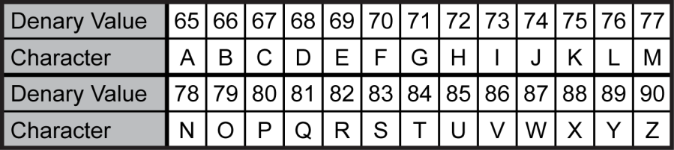
EBCDIC
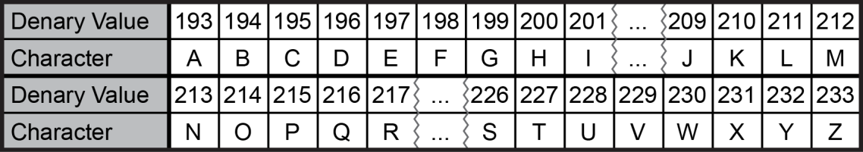
- Explain, referring to ASCII and EBCDIC, what would happen if computers were to use different character sets when communicating.
...........................................................................................................................................
...........................................................................................................................................
...........................................................................................................................................
...........................................................................................................................................
........................................................................................................................................... ....................................................................................................................................... [2]
PRACTICE PAPER
- Write a function that given the denary value of an EBCDIC uppercase letter, returns the denary value of an ASCII uppercase letter. If a value is entered that doesn’t correspond to an uppercase EBCDIC letter the function should return -1 e.g.
convert(201) returns 73 convert(209) returns 74 convert(78) returns -1
function convert(ebValue)
...........................................................................................................................................
...........................................................................................................................................
...........................................................................................................................................
...........................................................................................................................................
...........................................................................................................................................
...........................................................................................................................................
...........................................................................................................................................
...........................................................................................................................................
...........................................................................................................................................
...........................................................................................................................................
...........................................................................................................................................
...........................................................................................................................................
...........................................................................................................................................
...........................................................................................................................................
...........................................................................................................................................
endfunction
[5]

4 The following is a program written using the Little Man Computer instruction set.
start LDA OUT | one
LDA  OUT | zero
LDA | count
SUB | one
STA | count
BRP  HLT | start
one DAT | 1
zero DAT | 0
count DAT | 3
  - Describe the difference between the STA and LDA instructions.
...........................................................................................................................................
...........................................................................................................................................
...........................................................................................................................................
...........................................................................................................................................
....................................................................................................................................... [2]
  - State the output this program generates.
...........................................................................................................................................
...........................................................................................................................................
...........................................................................................................................................
...........................................................................................................................................
...........................................................................................................................................
...........................................................................................................................................
....................................................................................................................................... [3]

5 A software development company is building an operating system for a mobile phone that is in the process of being designed.
- Give one reason the phone needs an operating system.
...........................................................................................................................................
....................................................................................................................................... [1]
- Explain how the developers could use virtual machines.
...........................................................................................................................................
...........................................................................................................................................
...........................................................................................................................................
....................................................................................................................................... [2]

6 A flight simulator allows a user to take control of a simulated aeroplane. The user can fly the plane in an environment that can simulate different weather conditions and additional planes in the sky.
- Identify three pieces of information that would need to be researched in order to design this simulator.
  - ........................................................................................................................................... ..............................................................................................................................................
  - ........................................................................................................................................... ..............................................................................................................................................
  - ........................................................................................................................................... ......................................................................................................................................... [3]
(b) Air traffic controllers are considering introducing a new flight path.
Explain two reasons why they might use the new flight path in the simulation before implementing it in the real world.
  - ...........................................................................................................................................
.............................................................................................................................................. ..............................................................................................................................................
  - ...........................................................................................................................................
..............................................................................................................................................
..............................................................................................................................................
......................................................................................................................................... [4]

- Abstraction has been used in the design and creation of the flight simulator.
Explain, using an example, the need for abstraction in the creation of the flight simulator.
..............................................................................................................................................
..............................................................................................................................................
..............................................................................................................................................
..............................................................................................................................................
.............................................................................................................................................. [3]

7 A 1-dimensionsal array stores a set of numbered cards from 0 to 7. An example of this data is shown in Fig in 4.1
2 | 0 | 1 | 7 | 4 | 3 | 5 | 6
Fig 4.1
- The programmer wants to search for a specific card in the array.
State whether a binary search or a linear search would be the most appropriate method to search for a specific card, and justify your answer.
Search method .....................................................
Justification ...........................................................................................................................
..............................................................................................................................................
..............................................................................................................................................
......................................................................................................................................... [3]
- A programmer is writing a computer program to sort the cards into the correct order (0 to 7).
- Show how an insertion sort would sort the array in Fig 4.1 into the correct order. Draw the array after each move.
.......................................................................................................................................
.......................................................................................................................................
.......................................................................................................................................
.......................................................................................................................................
.......................................................................................................................................
.......................................................................................................................................
.......................................................................................................................................
.................................................................................................................................. [3]
8 A procedure is shown below.
  - procedure fun1(x)
  - y=""
  - if x < 0 then
  - flag = true
  - x = x * -1
  - endif
  - while (x > 0)
  - y = str(x MOD 2) + y
  - x = x DIV 2
  - endwhile
  - if flag == true then
  - y = "1" + y
  - else
  - y = "0" + y
  - endif
  - print(y) 17 endprocedure
flag is a local variable and has a default value of false.
- Explain why str is needed in line 08.
..............................................................................................................................................
..............................................................................................................................................
..............................................................................................................................................
..............................................................................................................................................
......................................................................................................................................... [3]
- (i) Show the result of y when the procedure is called with: fun1(10). Show your working.
y: .............................................................................................................................. [4]
(ii) Show the result of y when the procedure is called with fun1(-13). Show your working.
y: .............................................................................................................................. [4]

- In this procedure, flag is assumed to be a local variable.
  - Explain the problem that would be caused in this algorithm if flag was a global variable.
.......................................................................................................................................
.......................................................................................................................................
.......................................................................................................................................
.......................................................................................................................................
.......................................................................................................................................
.................................................................................................................................. [3]

END OF QUESTION PAPER

Copyright Information:
OCR is committed to seeking permission to reproduce all third-party content that it uses in its assessment materials. OCR has attempted to identify and contact all copyright holders whose work is used in this paper. To avoid the issue of disclosure of answer-related information to candidates, all copyright acknowledgements are reproduced in the OCR Copyright Acknowledgements Booklet. This is produced for each series of examinations and is freely available to download from our public website (www.ocr.org.uk) after the live examination series.
If OCR has unwittingly failed to correctly acknowledge or clear any third-party content in this assessment material OCR will be happy to correct its mistake at the earliest possible opportunity.
For queries or further information please contact the Copyright Team, First Floor, 9 Hills Road, Cambridge CB2 1GE.
OCR is part of the Cambridge Assessment Group. Cambridge Assessment is the brand name of University of Cambridge Local Examinations Syndicate (UCLES), which is itself a department of the University of Cambridge.
© OCR 2016

