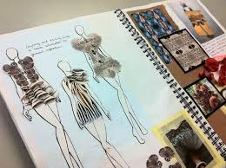
Summer project 2022-23
A-Level – Fashion and textiles
Task
Create your own personal fashion sketchbook. It will be an opportunity for you to unlock your creative mind, and challenge your ideas about fashion and what a fashion sketchbook should look like. You should collect and process inspiration from different and unusual sources, try out ideas, and take risks.

Details - Topics you could cover:
- Visual research and getting and using inspiration from different sources
- Present and develop your fashion ideas on your sketchbook
- Construct a visual narrative and developing concepts for a collection
- Fashion drawings
- Visits to cultural scenes, such as galleries, street markets, and specialist shops
- Exploring different techniques and media

Materials you could use:

A4 paper/sketchbook
A selection of drawing pencils F, H, HB, 1B, 2B(and mechanical pencils also)
Coloured pencils (water soluble or normal)
1 rubber
Crayons/other cheap drawing materials you like to use
Tracing paper
Masking tape
Paints (water colour/gouache/acrylic/poster paint)
Pastels or chalks
1 pritt stick
Plastic water pot (for water colours)
Paint brushes
1 small pot of PVA glue
Old copies of fashion magazine for cutting u
Outcomes
The outcome will be a collection of work in sketchbook form, a personal and varied set of fashion work that explores and investigates different and individual themes chosen by each student.
The students should leave the course feeling confident about working independently to design and develop fashion ideas.
You should finish having a sketchbook filled with design ideas for potential fashion collections and a new confidence to develop new designs.

