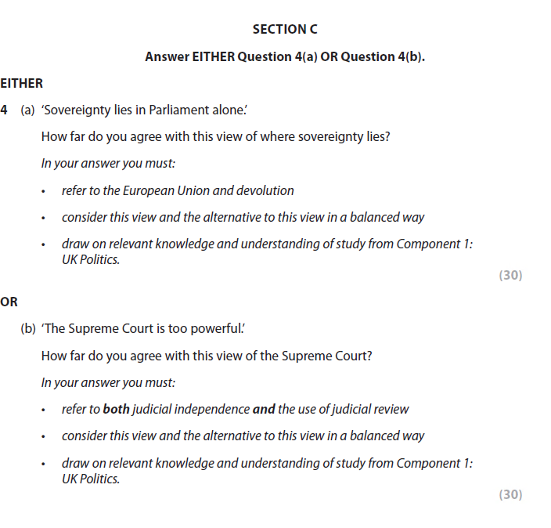
&

Students will complete both extended essay question from above, the answers should be at least two pages long (typed, size 11 font). You should aim for 45mins to complete each question.

