**DHFS**

**Mathematics - Year 1**

**Paper 1: Pure and Statistics**

|  |  |
| --- | --- |
| Paper 1 Pure and Statistics | |
| **You must have:**  mathematical formulae and statistical tables,  calculator | |
| Time allowed | 1 hour 45 minutes |

Write all of you answers on lined A4 paper.

Make sure you write your name and your teacher’s name at the top of every page.

|  |  |
| --- | --- |
| Total marks | /86 |

**SECTION A: Pure**

**Answer ALL questions**

**1** Find an equation of a line *l* which passes through *P*(−2, 6) and *Q*(4, −2).

Give your answer in the form *ax* + *by* + *c* = 0, where *a*, *b* and *c* are integers.

**(3)**

**(Total for Question 1 is 3 marks)**

**2** Point *P* lies on the line with equation 2*x* – *y* – 5 = 0.

Point *P* is a distance of  from the origin.

Show that there are two possible positions for point *P* and find the coordinates for each of these points.

Show each step of your working.

**(5)**

**(Total for Question 2 is 5 marks)**

**3** The points *P*(−5, −13) and *Q*(7, 3) lie on a circle *C* with centre (*a*, −8) and radius *r*.

Find the equation of the circle *C*.

**(8)**

**(Total for Question 3 is 8 marks)**

**4** The equation *kx*2 – 3*kx* + 15 = 0, where *k* is a constant, has two real roots.

Prove that *k* < 0 or *k* > .

**(3)**

**(Total for Question 4 is 3 marks)**

**5** Figure 1shows a triangle, *ABC*.

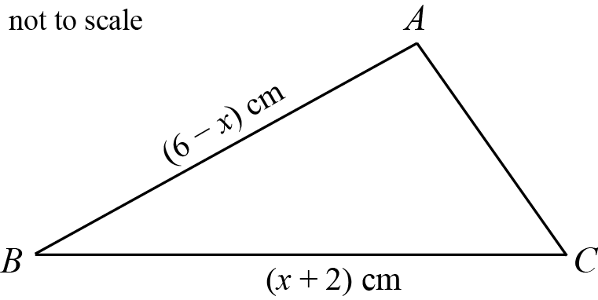

**Figure 1**

*ABC* = 30°

*AB* = (6 – *x*) cm

*BC* = (*x* + 2) cm.

The area of the triangle is .

**a** Show that .

(**3)**

**b** Find the maximum value of *A* and the value of *x* at which it occurs.

**(4)**

**(Total for Question 5 is 7 marks)**

**6** Solve for .

Give you’re answers to one decimal place.

**(5)**

**(Total for Question 6 is 5 marks)**

**7** Prove, from first principles, that the derivative of 4*x*3 is 12*x*2.

**(4)**

**(Total for Question 7 is 4 marks)**

**8** 

The magnitude of  is 

Find the possible values of *k*, leaving your answer in simplified surd form.

**(3)**

**(Total for Question 8 is 3 marks)**

**9** Figure 2 shows a line with equation *x* + *y* = 11.

It intersects a curve with equation  at the points *P* and *Q*.

The shaded region *R*1 is a trapezium bounded by *PQ*, the *x*-axis and lines parallel to the *y*-axis through *P* and *Q*.

The shaded region *R*2 is the finite region bounded by the line and the curve.

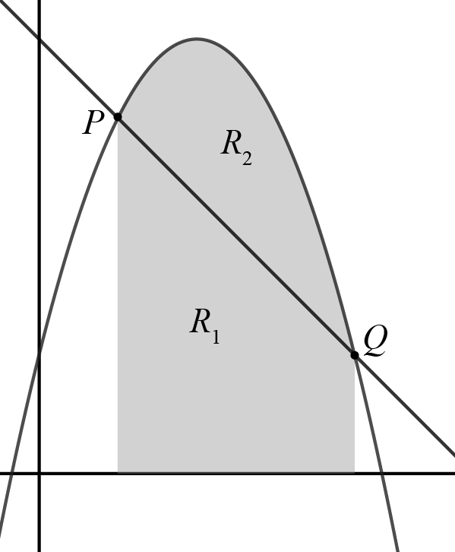

**Figure 2**

Show that the areas of the shaded regions *R*1 and *R*2 are in the ratio 2:1.

**(8)**

**(Total for Question 9 is 8 marks)**

**10** Figure 3 shows the plan view of a garden where part of the garden has been enclosed with 250 m of fencing.

The shape of the enclosed part of the garden is a rectangular section joined to a semicircular section.

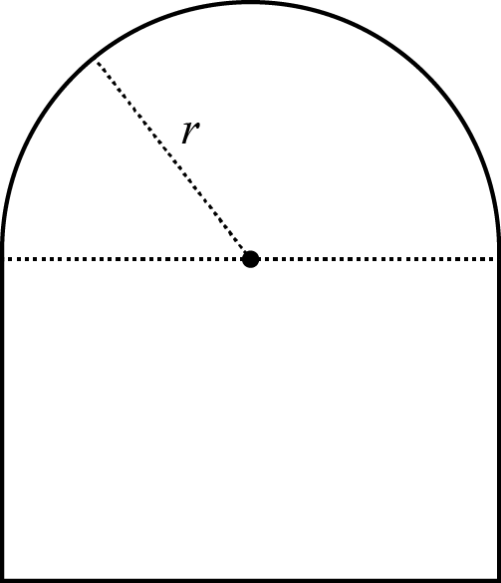

**Figure 3**

Given that the radius of the semicircular section is *r* metres, show that,

**a** the area, *A* m2, of the enclosed part of the garden is given by 

**(5)**

**b** the maximum value of the area of the enclosed part of the garden is 

**(5)**

**(Total for Question 10 is 10 marks)**

**______________________________________________________________________________________ TOTAL FOR SECTION A IS 56 MARKS**

**SECTION B: STATISTICS**

**Answer ALL questions**

**11** Briony investigated the variation in daily mean air temperature, *x* °C, for Beijing in May and June 2015.

She used the large data set to select a sample of size 15.

She selected the first value by generating a random number between 1 and 61 and then selected every fourth value after that.

**a** State the sampling technique that Briony used.

**(1)**

Briony summarised the data and found,

*n* = 15, , 

**b** Calculate the standard deviation.

**(2)**

An outlier is defined as,

*‘a data value which is more than two standard deviations from the mean’*.

**c** Show that the temperature recorded on 10 May, 9.7 °C, is an outlier.

**(1)**

**d** Clean the data and recalculate the mean and standard deviation for the new data set.

**(3)**

**e** From your knowledge of the large data set, explain why Briony’s sampling process might not generate a sample of size 15.

**(1)**

**(Total for Question 11 is 8 marks)**

**12** The Venn diagram, Figure 1, shows the probabilities for children at a nursery taking part in various activities.

*P* represents the event that a child takes part in finger painting.

*Q*represents the event that a child takes part in music.

*R* represents the event that a child takes part in water play.

*x* and *y* are probabilities.

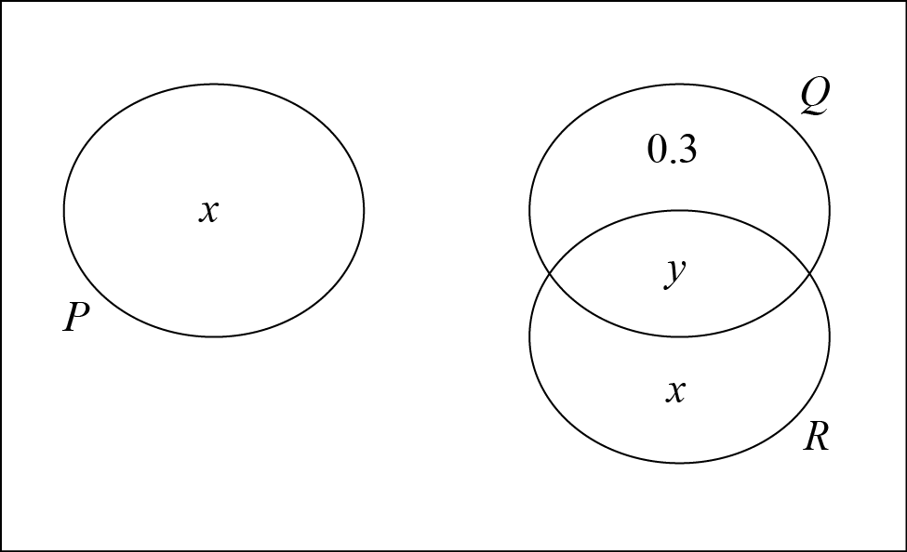

**Figure 1**

All the children take part in at least one activity.

The probability that they do not take part in music is 0.3

**a** Find the values of *x* and *y*.

**(2)**

**b** Find the probability that a randomly selected child takes part in music or painting.

**(1)**

**c** State, giving a reason, whether or not the events *Q* and *R* are statistically independent.

Show your working clearly.

**(3)**

**(Total for Question 12 is 6 marks)**

**13** Historical data suggests that 20% of motorists regularly exceed the speed limit on a motorway.

A new law is introduced increasing the penalties for speeding and the police suspect that there has been a reduction in the number of motorists speeding.

A random sample of 30 motorists is taken.

**a** Write down the hypotheses that should be used to test the police’s suspicion.

**(1)**

**b** Find the critical region for the test.

Use a significance level of 5%.

**(2)**

On a particular day, the police observe that three of the 30 motorists sampled exceeded the speed limit.

**c** Comment on the police’s claim in the light of this observation.

**(1)**

It was later discovered that all the motorists in the sample were part of the same race club.

**d** Comment on the validity of the model used.

**(1)**

**(Total for Question 13 is 5 marks)**

**14** A discrete random variable *X* is modelled using the probability function,



**a** Write down, in terms of *k*, *P*(*X* = 2).

**(1)**

**b** Find the value of *k*.

**(2)**

Josh has a biased, four-sided dice that he claims can be modelled using the probability function given above.

He rolls the dice 300 times.

His results are shown in the table,

|  |  |  |  |  |
| --- | --- | --- | --- | --- |
| **Score** | 1 | 2 | 3 | 4 |
| **Frequency** | 10 | 38 | 120 | 132 |

**c** Use the results in the table to find an estimate for the probability that Josh rolls a two.

**(1)**

**d** Comment on the suitability of the model.

**(2)**

**(Total for Question 14 is 6 marks)**

**15** Ahmed is investigating the relationship between daily total rainfall (*x* mm) and daily total sunshine (*y* hours) in Leeming in July 2015.

**a** Describe the type of data represented by daily total rainfall.

**(1)**

Ahmed drew a scatter diagram for the data, as shown in Figure 2.

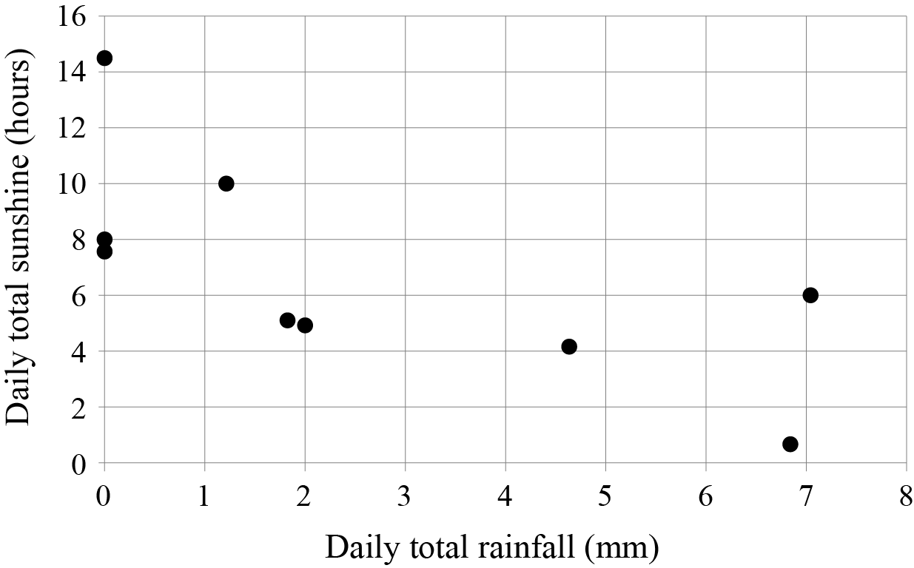

**Figure 2**

**b** Describe the type of correlation shown.

**(1)**

He calculates the equation of the regression line of *y*-on-*x* to be

**c** Give an interpretation of the value 9.34 in the equation of the regression line.

**(1)**

Ahmed had a tenth data value for total daily rainfall, but the total daily sunshine was missing.

**d** Evaluate the usefulness of outcome of Ahmed’s model for the tenth day when the daily total rainfall was 10.1 mm.

(**2)**

**(Total for Question 15 is 5 marks)**

**TOTAL FOR SECTION B IS 30 MARKS**

**TOTAL FOR PAPER IS 86 MARKS**