**Mathematics**

**Advanced**

**Paper 1: Pure Mathematics 1**

|  |  |
| --- | --- |
| Paper 1 Pure Mathematics 1 | |
| **You must have:**  Mathematical Formulae and Statistical Tables,  calculator | |
| Time allowed | 2 hours |

Write all of you answers on lined A4 paper.

Make sure you write your name and your teacher’s name at the top of every page.

|  |  |
| --- | --- |
| Total marks | /100 |

**1** Given that (*x* + 2) and (*x* – 1) are factors of *px*3 + 5*x*2 + *qx* – 6 = 0,

**a** find the values of *p* and *q*.

**(4)**

**b**  Hence sketch the graph of *y* = *px*3 + 5*x*2 + *qx* − 6 labelling all points of intersection with the coordinate axes.

**(4)**

**(Total for Question 1 is 8 marks)**

**2** A function is defined by,

for all values of *θ*

**a** State the range of values of the constant *k* for which  has no solutions.

**(2)**

**b** Solve ****in the interval .

**(4)**

**(Total for Question 2 is 6 marks)**

**3** The ninth term of an arithmetic series is 36.

The thirteenth term is 16.

The sum of the first *n* terms is 400.

**a** Show that 5*n*2 – 157*n* + 800 = 0

**(5)**

**b** Hence find the value of *n*.

**(2)**

**(Total for Question 3 is 7 marks)**

**4** **a** Find , where *k* is constant, giving your answer in terms of *k.*

**(4)**

**b** Given , find the exact value of *k*.

**(1)**

**(Total for Question 4 is 5 marks)**

**5** Environmentalists are modelling the number of people, *N*, in thousands, affected by a nuclear meltdown *t* hours after the meltdown occurs.

The line *l* shown in Figure 1 illustrates the linear relationship between *t* and log10 *N* for the first 20 hours.

The line *l* meets the vertical axis at (0, 2.1), as shown.

The gradient of *l* is0.1.

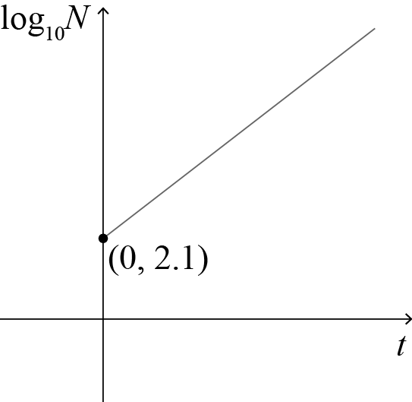

**Figure 1**

**a** Write down an equation for *l*.

**(2)**

The environmentalists wish to write the relationship between *N* and *t* in the form *N = abt*.

**b** Find the value of *a* and the value of *b* correct to 3 significant figures.

**(4)**

**c** With reference to the model, interpret the value of *a* and the value of *b*.

**(2)**

**d** Find the population affected, to the nearest 1000, by the model when *t* = 15.

**(1)**

**e** Find the number of hours it takes for the population afftected to reach 8 000 000.

**(2)**

**f** State one reason why this may not be a realistic model.

**(1)**

**(Total for Question 5 is 12 marks)**

**6** Figure 2 shows a sketch of part of the graph , where



The graph intercepts the *y*-axis at (0, −8).

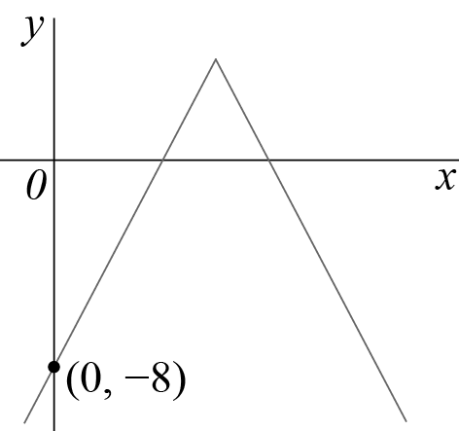

**Figure 2**

**a** Find the value of *a*.

**(1)**

**b** Solve

**(4)**

**(Total for Question 6 is 5 marks)**

**7** **a** Prove that,

**(4)**

**b** Explain why the equation does not have any real solutions.

**(2)**

**(Total for Question 7 is 6 marks)**

**8** Figure 3 shows the curve with equation,

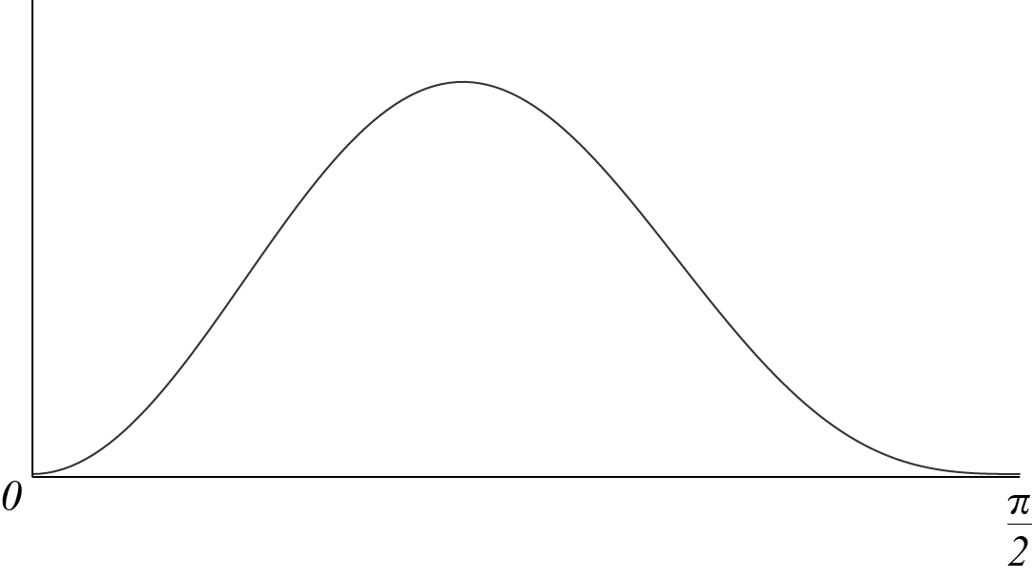

**Figure 3**

**a** Giving your answers to 4 significant figures, complete the table with the value of *y* corresponding to .

**(1)**

|  |  |  |  |  |  |  |
| --- | --- | --- | --- | --- | --- | --- |
| *x* | 0 |  |  |  |  |  |
| *y* | 0 | 0.0821 | 0.1829 | 0.1329 |  | 0 |

**b** Given that ,

**i** use the trapezium rule with five strips to find an approximate value for *I, g*iving your answer to 4 significant figures.

**(3)**

**ii** Explain how the trapezium rule could be used to obtain a more accurate estimate of the integral.

**(1)**

**c** By using an appropriate substitution, or otherwise, find the exact value of *I*.

**(6)**

**(Total for Question 8 is 11 marks)**

**9** A function is defined by,

**a** Show f (*x*) = 0 has a root *α* in the interval [5.7, 5.8].

**(2)**

**b** A student takes 5.7 as a first approximation to *α*.

Given f '(5.7) = 6.8786 to 5 significant figures, apply the Newton-Raphson procedure once to obtain a second approximation for *α*, giving your answer to 3 decimal places.

**(2)**

**c** Sketch a graph to show that there are exactly two roots of f (*x*) = 0.

**(2)**

**(Total for Question 9 is 6 marks)**

**10** A student states, ‘if  is an irrational number, then at least one of *a* and *b* is an irrational number’.

**a** Use proof by contradiction to prove that the student is correct.

**(4)**

He also states, ‘if  is a rational number, then both *a* and *b* are rational numbers.’

**b** Show that this statement is not true.

**(1)**

**(Total for Question 10 is 5 marks)**

**11** Figure 4 shows rectangle *ACDE* with  and .

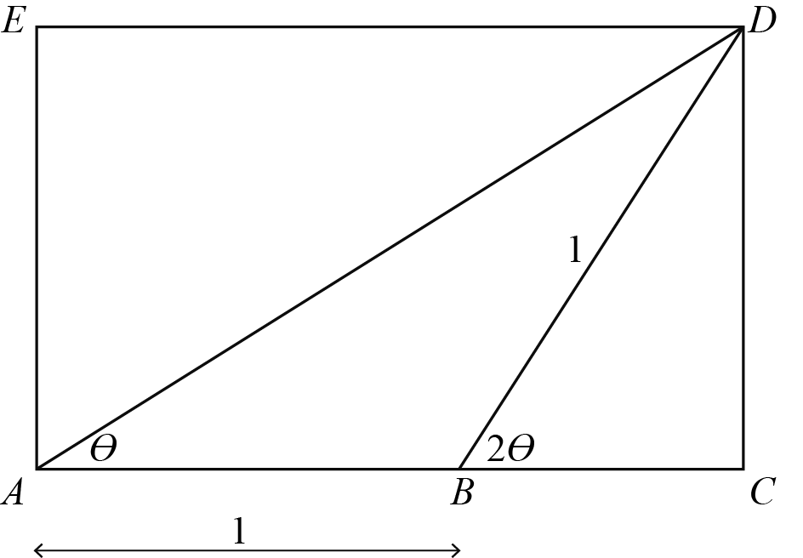

**Figure 4**

**a** Show that .

**(3)**

**b** Hence prove that .

**(3)**

**(Total for Question 11 is 6 marks)**

**12** The curve *C* has parametric equations,

**a** Find an expression for  in terms of *t*.

**(2)**

The point *P* lies on *C* where . The line *l* is normal to *C* at *P*.

**b** Show that the equation for *l* is .

**(5)**

The line *l* intersects the curve *C* again at *Q*.

**c** Find the exact coordinates of *Q*.

You must show clearly how you obtained your answers.

**(6)**

**(Total for Question 12 is 13 marks)**

**13** Figure 5 shows a cyclindrical-shaped barrel of diameter 40 cm. It holds rain water.

Rain water flows out of the tap near the bottom of the barrel at a rate proportional to the square root of the volume.

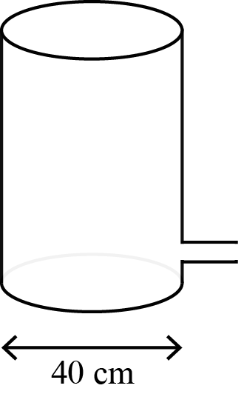

**Figure 5**

**a** Show that, at *t* seconds after the tap is opened,  for some constant *k*.

**(4)**

**b** Show that the general solution to this differential equation is .

**(3)**

Initially, the height of the water is 64 cm. 30 seconds later, the height of the water is 25 cm.

**c** Find the value of the constants *A* and *B*.

**(2)**

**d** Explain why it might not be appropriate to use the model to calculate the time when the height of the water is 1 cm.

**(1)**

**(Total for Question 13 is 10 marks)**

**TOTAL FOR PAPER IS 100 MARKS**