**Mathematics**

**Advanced**

**Paper 2: Pure Mathematics 2**

|  |  |
| --- | --- |
| Paper 2 Pure Mathematics 2 | |
| **You must have:**  Mathematical Formulae and Statistical Tables,  Calculator | |
| Time allowed | 2 hours |

Write all of you answers on lined A4 paper.

Make sure you write your name and your teacher’s name at the top of every page.

|  |  |
| --- | --- |
| Total marks | /100 |

**1**



where *k* is a rational number.

**a** Find the series expansion of f (*x*), in ascending powers of *x*, up to and including the *x*3 term.

**(3)**

**b** State the value of *k*.

**(1)**

**(Total for Question 1 is 4 marks)**

**2** The line *l*1 passes through the points *P*(5, 8) and *Q*(15, 16).

The line *l*2 is perpendicular to *l*1 and passes through the point *P*.

The line *l*1 intersects the *y*-axis at *A* and the line *l*2 intersects the *y*-axis at *B*.

Find the area of the triangle *APB*.

**(8)**

**(Total for Question 2 is 8 marks)**

**3** A circle has equation *x*2 + 6*x* + *y*2 – 4*y* – 32 = 0.

**a** Show that the radius of the circle is of the form , where *a* is a constant to be found.

**(2)**

**b** Find the coordinates of the centre of the circle.

**(1)**

**c** The points *A*(−9, −1) and *B*(3, 5) both lie on the circumference of the circle.

Show that *AB* is the diameter of the circle.

**(2)**

**d** The point *D* lies on the negative *y*-axis and the angle *ADB* = 90°.

Find the coordinates of *D*.

**(3)**

**(Total for Question 3 is 8 marks)**

**4** A basketball player throws a basketball.

The height, *h* metres, of the basketball above the ground is modelled by the formula,

where *x* is the horizontal distance of the basketball from the player, measured in metres.

The basketball travels in a vertical plane until it either hits the hoop or the ground.

**a** With reference to the model, interpret the significance of the constant 1.9 in the formula.

**(1)**

**b** Write  in the form , where *A*, *B* and *C* are constants to be found.

**(3)**

**c** State the greatest height of the basketball and the horizontal distance when it occurs.

**(2)**

**(Total for Question 4 is 6 marks)**

**5** Find the exact solutions to the equation 2*ex* + 15*e−x* = 13.

You must show clearly how you obtained your answer.

**(4)**

**(Total for Question 5 is 4 marks)**

**6** The functions p and q are defined by,



Solve , giving your answers in exact form.

**(5)**

**(Total for Question 6 is 5 marks)**

**7** The curve *C* has parametric equations,



Show that the Cartesian equation of the curve can be written in the form,



where *a*, *b* and *c* are constants to be found.

**(5)**

**(Total for Question 7 is 5 marks)**

**8** Show that 

**(7)**

**(Total for Question 8 is 7 marks)**

**9** The population of lions in a national park was 2400 at the beginning of 2008.

A model predicts that the lion population will decrease by 2% each year.

The model predicts that after *n* years, the population will be first below 1600.

**a** Show that 

**(4)**

A conservation agency wishes to raise £1000 per lion per year based on the number of lions predicted to be in the park at the start of each year.

**b** Calculate the total amount raised, to the nearest £1000, between the beginning of 2008 and the end of 2016.

**(3)**

**c** Explain why this model of fundraising might not be effective.

**(1)**

**(Total for Question 9 is 8 marks)**

**10** Figure 1 shows a circle with centre *O* and radius *r*.

The chord *AB* divides the circle into a minor segment *R*1 and a major segment *R*2.

The chord *AB* subtends an angle *ϴ* at *O*.

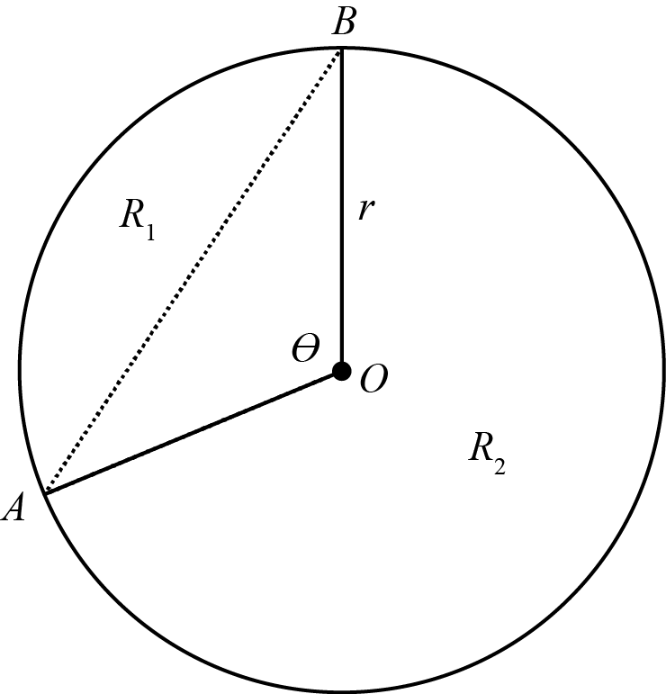

**Figure 1** [not to scale]

**a** Show that the area of *R*1 is .

**(2)**

**b** Given that the ratio of the areas of *R*1 to *R*2 is 1:9, show that .

**(3)**

**(Total for Question 10 is 5 marks)**

**11** Figure 2 shows curve *C* with equation *y* = f (*x*)

where 

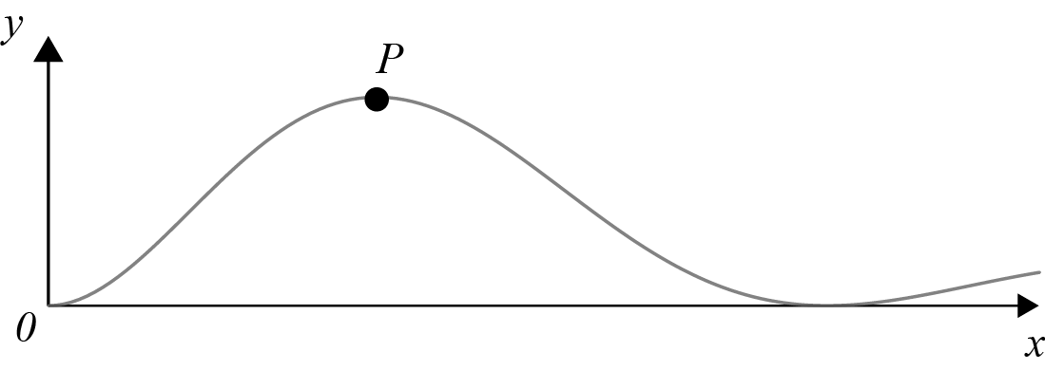

**Figure 2**

The curve has a local maximum turning point at *P*.

**a** Show that the *x*-coordinate of point *P* is a solution of the equation tan *x* = 4.

**(6)**

**b** Using your answer to part **a**, find the *x*-coordinate of the maximum turning point on

*y* = 1 + 4f (2*x*).

**(2)**

**(Total for Question 11 is 8 marks)**

**12** The points *A*, *B* and *C*, with position vectors (−5, 4, 7), (−15, 8, 12) and (−13, 12, 1) respectively, form a triangle *ABC*.

**a** Show that triangle *ABC* is isosceles.

**(2)**

**b** Calculate the size of angle *ABC*.

**(2)**

**(Total for Question 12 is 4 marks)**

**13 a** Show that, when  is small, the equation  can be written as 

**(3)**

**b** Hence write down the value of  when  is small.

**(1)**

**(Total for Question 13 is 4 marks)**

**14** Prove by contradiction that  is an irrational number.

**(5)**

**(Total for Question 14 is 5 marks)**

**15** The value of a car can be modelled by the function,

where,

*V* is the value of the car in thousands

*t* is the time in years since the car was purchased.

**a** Express  in the form , where *R* > 0 and 0 <  < .

Give the exact value of *R* and the value of , in radians, to 2 decimal places.

**(3)**

**b** Find the time, in years, that it will take for the car to be worth half of its original purchase price.

**(4)**

**c** Find the time taken for the value of the car to reach its minimum value.

**(2)**

**d** Explain with a reason why this model is not valid for large values of *t*.

**(1)**

**(Total for Question 15 is 10 marks)**

**16** The number of confirmed cases, *D*, per year, of a disease is decreasing. The rate of decrease is proportional to the number of confirmed cases per year.

**a** Given that initially the number of confirmed cases is *D*0, show that D = *D*0*e*−*kt*

**(5)**

It is known that after 15 years there are only  of the initial confirmed cases per year.

**b** Find the exact value of *k*.

**(3)**

**c** Will the disease ever be eliminated?

Explain your answer.

**(1)**

**(Total for Question 16 is 9 marks)**

**TOTAL FOR PAPER IS 100 MARKS**