Mathematics
Advanced
Paper 3: Statistics and Mechanics

Paper 3 Statistics and Mechanics
You must have:
Mathematical Formulae and Statistical Tables,
calculator
Time allowed | 2 hours

Write all of you answers on lined A4 paper.

Make sure you write your name and your teacher’s name at the top of every page.

Total marks | /100

SECTION A: STATISTICS
Answer ALL questions
1 Sanjida sometimes takes the bus to school. The rest of the time she gets a lift.
In each case, there is a chance that she is late.
The tree diagram, Figure 1, shows the various probabilities.

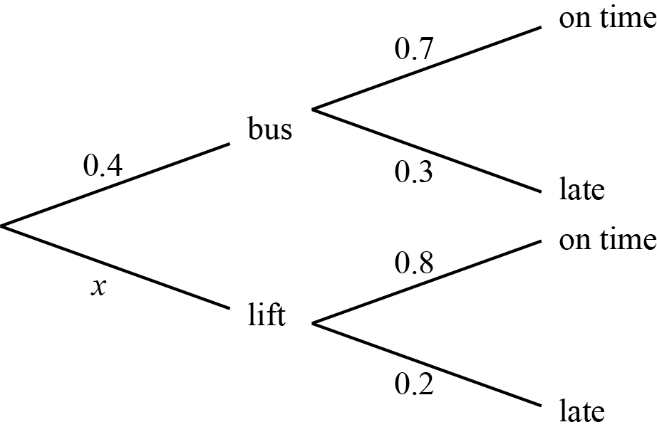
Figure 1

a Write down the value of x.
(1)
b Calculate the probability that Sanjida is late to school.
(2)
Event A is defined as, ‘Sanjida is late to school’.
Event B is defined as, ‘Sanjida has a packed lunch’.
Given that
c explain why events A and B are not independent
(1)
d calculate P(A’|B’).
(2)

(Total for Question 1 is 6 marks)

2 Siobhan is investigating the daily mean atmospheric pressure in Beijing.
She takes a sample from the 2015 weather data by selecting the first date at random and then choosing every twentieth data point thereafter.
a State the sampling method Siobhan is using.
(1)
She records her data in Table 3. All values are in hPa.

1010 | 1008 | 990 | 1012 | 1012 | 1000 | 998 | 1005 | 1010
Table 3

b Use Siobhan’s data to estimate the probability that, for a randomly chosen date, the daily mean pressure will be greater than 1000 hPa.
(1)
Siobhan calculates the mean of her sample to be 1005 and the standard deviation to be 7.12.
An outlier is defined as a data value more than two standard deviations from the mean.
c Show that 990 is an outlier.
(1)
d Clean the data and recalculate the mean.
(1)
e Suggest a way that Siobhan can improve the reliability of any conclusions she draws.
(1)

(Total for Question 2 is 5 marks)

3 The daily maximum temperature, t °C, for the month of June at Heathrow is summarised in Table 1.

Daily maximum temperature, t °C | 15 ⩽ t < 20 | 20 ⩽ t < 22 | 22 ⩽ t < 25 | 25 ⩽ t < 30 | 30 ⩽ t < 35
Frequency | 6 | 10 | 7 | 6 | 1
Table 1

a Use your calculator to estimate the
i mean
ii standard deviation
of the daily maximum temperature for the month of June at Heathrow.
(2)
The upper quartile for the data is given as 25 °C.
b Calculate an estimate for the interquartile range (IQR).
(3)
Simon calculates the IQR for the daily maximum temperature in Leuchars, Scotland in the same month to be 4.8.
He claims that, the further north you go, the more variable the daily maximum temperature.
c Comment on Simon’s claim.
(1)
Simon now models the daily maximum temperature at Heathrow by N(22.6, 3.8²).
d Using this model, find the probability that the daily maximum temperature lies between the lower and upper quartiles.
(2)
e Using your answer to part d, comment on the suitability of Simon’s model.
(1)

(Total for Question 3 is 9 marks)

4 Francine lives in Perth. She is investigating the relationship between the daily total rainfall, x, and the daily mean wind speed, y.
She takes a random sample of eight days from weather data collected in 2015, as shown in Table 2.

Daily total rainfall, x mm | 6.6 | 35.0 | 9.8 | 2.0 | 12.2 | 18.6 | 13.0 | 15.8
Daily mean wind speed, y knots | 6.4 | 14.1 | 9.4 | 5.2 | 9.3 | 10.1 | 8.6 | 8.8
Table 2

a State the type of data recorded for daily total rainfall.
(1)
b Use your calculator to find the value of the product moment correlation coefficient for these data.
(1)
Francine claims that the value of the product moment correlation coefficient shows that there is a positive correlation between the daily total rainfall and the daily mean wind speed.
c Test Francine’s claim, using a 1% level of significance.
State your hypotheses clearly.
(3)
Francine calculates the equation of the regression line of y-on-x to be
y = 5.3872 + 0.255x
d State, with a reason, whether Francine is justified in using a regression line for these data.
(1)
e Use Francine’s regression line to predict the daily mean wind speed when there is 20 mm of rainfall.
(1)
f Explain why Francine should not use her regression line to predict the daily mean wind speed when there is 50 mm of rainfall.
(1)

(Total for Question 4 is 8 marks)

5 A company makes light bulbs.
The marketing manager claims that 60% of the company’s light bulbs last longer than 4000 hours.
a Explain why the company should take a sample of light bulbs to test this claim, rather than testing all of the light bulbs.
(1)
A random sample of 25 light bulbs is chosen.
These light bulbs are then tested.
b Write down the distribution of the random variable X, where X is the number of light bulbs in the sample that last longer than 4000 hours.
(1)
c Calculate P(X = 18).
(1)
Nine further, independent random samples of 25 light bulbs are taken.
d Find the probability that in six or more of the ten samples, fewer than 16 light bulbs last longer than 4000 hours.
(3)

(Total for Question 5 is 6 marks)

6 In a manufacturing process 25% of articles are thought to be defective. Articles are produced in batches of 20
a A batch is selected at random. Using a 5% significance level, find the critical region for a two tailed test that the probability of an article chosen at random being defective is 0.25
You should state the probability in each tail which should be as close as possible to 0.025
(5)
The manufacturer changes the production process to try to reduce the number of defective articles. She then chooses a batch at random and discovers there are 3 defective articles.
b Test at the 5% level of significance whether or not there is evidence that the changes to the process have reduced the percentage of defective articles. State your hypotheses clearly.
(5)
(Total for Question 6 is 10 marks)

7
A student takes a multiple choice test. The test is made up of 10 questions each with 5 possible answers. The student gets 4 questions correct. Her teacher claims she was guessing the answers. Using a one tailed test, at the 5% level of significance, test whether or not there is evidence to reject the teacher's claim. State your hypotheses clearly.
(6)
(Total for Question 7 is 6 marks)

TOTAL FOR SECTION A IS 50 MARKS

SECTION B: MECHANICS
Answer ALL questions
8 State the correct SI units for,
a i velocity
(1)
ii weight.
(1)
b A car accelerates from rest to 7.2 km h⁻¹ in 4 s.
Show that this is an acceleration of 0.5 m s⁻².
(2)

(Total for Question 7 is 4 marks)

9 At t = 0 seconds, a car begins to decelerate at a constant rate from 20 m s⁻¹ to 10 m s⁻¹ over a period of 5 seconds.
It then maintains its speed for a further 5 seconds before decelerating at a constant rate and coming to rest in 10 seconds.
a Draw a velocity–time graph to show the motion of the car between t = 0 and t = 20 seconds.
(4)
b Calculate the acceleration of the car in the first five seconds.
(2)
c Work out the total distance travelled by the car.
(3)

(Total for Question 9 is 9 marks)

10 Figure 2 shows a particle of mass m kg suspended by one lightweight string that cannot be stretched.
The string is attached to a vertical wall at point A.
It makes an angle of α to the vertical.
A horizontal force, P, keeps the particle in equilibrium.

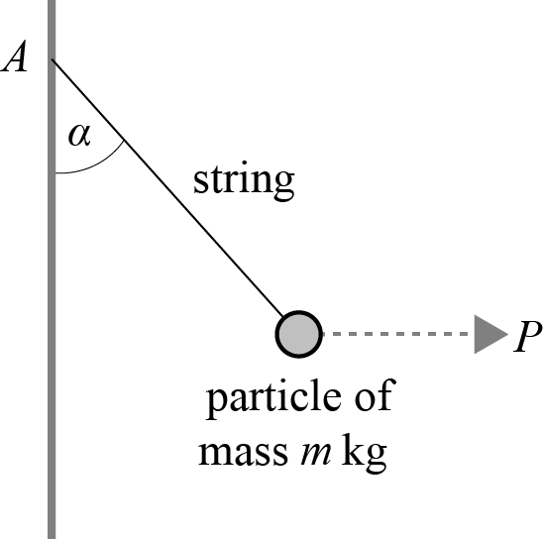
Figure 2

Show that
(3)

(Total for Question 9 is 3 marks)

11 A box sits motionless on a rough inclined plane.
a Draw a diagram to show all the forces acting on the box.
Write the name of each force clearly.
(3)
b A force of P N is applied to the box parallel to the slope, causing the box to accelerate up the slope at 3 m s⁻².
The box has a mass of 5 kg.
The slope is angled at α to the horizontal where
The coefficient of friction is 0.2.
Find the value of P.
(6)
After five seconds, the force P is removed.
c Work out how long it take the box to come to a complete stop.
(5)

(Total for Question 10 is 14 marks)

12 A uniform plank, AC, of length 10 m and mass 12 kg, lies on the edge of a vertical cliff, as shown in Figure 3.

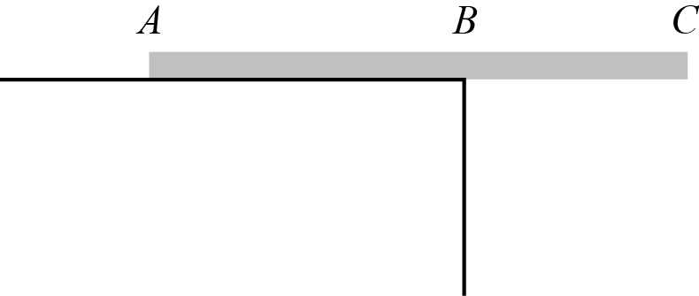
Figure 3

A mass of 5 kg is attached to the plank at C.
Given that the plank is on the point of tipping, work out the distance BC.
(3)

(Total for Question 11 is 3 marks)

13 A ball is projected from point A with speed 20 m s⁻¹ at an angle of α to the horizontal.
Point A is 40 m above the horizontal plane and the ball lands at point B, 4 seconds after being projected.
a Work out the value of α.
(4)
b Show that the horizontal distance between A and B is 70.2 m.
(4)

(Total for Question 12 is 8 marks)

14 A particle P moves in a horizontal plane.
At time t, the velocity of P is given by,
v = at²i + 3tj
where a is a positive constant.
At t = 1 second, the acceleration of the particle is 5 m s⁻².
a Show that a = 2.
(4)
b At t = 0, the particle is at the origin O.
Work out the distance between the particle and the origin after three seconds of its motion.
(5)

(Total for Question 13 is 9 marks)
TOTAL FOR SECTION B IS 50 MARKS
TOTAL FOR PAPER IS 100 MARKS

