**DHFS**

**Mathematics - Year 1**

**Paper 2: Pure and Mechanics**

|  |  |
| --- | --- |
| Paper 2 Pure and Mechanics | |
| **You must have:**  mathematical formulae and statistical tables,  calculator | |
| Time allowed | 1 hour 30 minutes |

Write all of your answers on lined A4 paper.

Make sure you write your name and your teacher’s name at the top of every page.

|  |  |
| --- | --- |
| Total marks | /74 |

**SECTION A: PURE**

**Answer ALL questions**

**1** A freelance journalist charges an initial fixed fee and then an extra fee per word.

She charges £250 for a 300 word article and £410 for a 700 word article.

**a** Write an equation linking words, *w*, and fee, *F*, in the form *F* = *aw* + *b*.

**(3)**

**b** Interpret the values of *a* and *b*.

**(2)**

She charges a company £650 to write another article.

**c** Calculate the word length of this article.

**(2)**

**(Total for Question 1 is 7 marks)**

**2** Given that , express each of the following in the form , where *k* and *n* are constants.

**a** 

**(2)**

**b** 

**(2)**

**(Total for Question 2 is 4 marks)**

**3** A company expects to sell 20 000 computers in the first year if the price of each computer is £650.

Let *x* represent the number of £’s by which the price has decreased.

**a** Write an expression for the price, *p*, of one computer, in the form *p* = *a* + *bx*.

**(1)**

The companyexpects to sell an additional 50 computers every time the price decreases by £1.

**b** Write an expression for the number of computers sold, *C*, in the form *C* = *d* + *ex*.

**(1)**

Revenue is defined by the formula,

revenue = (number of computers sold) × (cost of one computer)

**c** Write an equation for revenue, *r*, in the form *A* – *B*(*x* – *C*)2, where *A*, *B* and *C* are constants to be found.

**(4)**

The company wishes to maximise the revenue.

**d** Using your answer to part **c**, or othwerwise, state the price the company should charge for each computer and the revenue they will attain.

**(2)**

**(Total for Question 3 is 8 marks)**

**4** f(*x*)= *x*2 – 7*x* + 10

g(*x*) = 6 – 2*x*

**a** Sketch the graphs of *y* = f(*x*) and *y* = g(*x*) on the same axes.

**(4)**

**b** Find the coordinates of any points of intersection.

**(4)**

**c** Write down the sets of values of *x* for which g (*x*) > f (*x*).

**(1)**

**(Total for Question 4 is 9 marks)**

**5** Prove that, for any positive numbers *a* and *b*, where , 

**(3)**

**(Total for Question 5 is 3 marks)**

**6** In the binomial expansion of (1 + *px*)8, the coefficient of *x*3 is 252 times the coefficient of *x*.

Find the value of the coefficient of *x*2.

**(5)**

**(Total for Question 6 is 5 marks)**

**7** The value, *V* in £’s, of a car *t* years after purchase can be modelled by the equation,

**a** State the initial value of the car.

**(1)**

**b** Interpret the meaning of the 2000 in the model.

**(1)**

**c** Find  and state how shows the value of the car decreases over time.

**(2)**

**d** Show that, when the value of the car is £18  000, .

**(4)**

**(Total for Question 7 is 8 marks)**

**TOTAL FOR SECTION A IS 44 MARKS**

**SECTION B: MECHANICS**

**Answer ALL questions**

Unless otherwise indicated, whenever a numerical value of *g* is required, take *g* = 9.8 m s−2 and give your answer to either 2 significant figures or 3 significant figures.

**8** A remote-control car accelerates along a straight race track.

The velocity­–time graph (Figure 3) shows the motion of the remote-control car over a period of 25 seconds. The points A and B on the graph have coordinates (5, 10) and (15, 10) respectively.

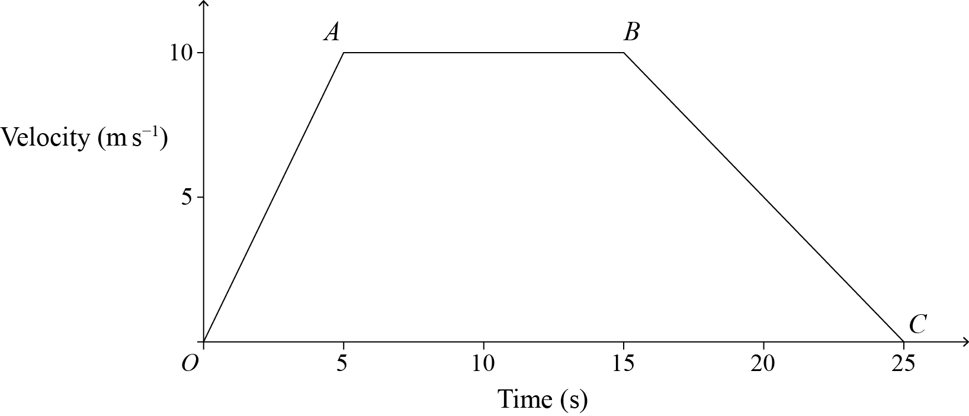

**Figure 3**

**a** Describe what is happening to the direction of travel of the remote-control car.

**(1)**

**b** Describe the motion of the car between,

**i** *O* and *A*

**(1)**

**ii** *A* and *B*.

**(1)**

**c** Calculate the total distance travelled by the car.

**(2)**

**(Total for Question 8 is 5 marks)**

**9** A particle of mass 5 kg is at rest under the action of three forces,

*F*1 = 8**i** − 2**j**, *F*2 = *a***i** + *b***j** and *F*3 = *a***i** – **j**

**a** Find the values of the constants *a* and *b.*

**(3)**

The direction of the force *F*1 is reversed.

**b** Find the acceleration of the particle. Give your answer in vector form.

**(3)**

**(Total for Question 9 is 6 marks)**

**10** A train engine of mass 12 tonnes is pulling a carriage of mass 6 tonnes along a horizontal track.

The engine produces a constant driving force of 10 kN.

The resistance to motion is 5000 N on the engine and 3000 N on the carriage.

The engine and the carriage are connected by a shunt.

**a** Show that the train is accelerating atm s−2.

**(3)**

When the train is travelling at 30 m s−1, the shunt fails.

**b** Work out how long it takes the carriage to come to a halt.

**(3)**

**c** State one modelling assumption you have made in answering part **b**.

**(1)**

**(Total for Question 10 is 7 marks)**

**11** A ball *B* moves along a straight line.

*B* is initially at rest at the point *O*.

At time *t* s, the velocity of *B* is *t*(1 − *t*2)  m s−1.

Show that the maximum velocity of the ball ism s−1.

**(5)**

**(Total for Question 11 is 5 marks)**

**12** A ball is dropped from rest from a height of *h* metres onto a horizontal surface.

After striking the floor, it rebounds to half its original height.

Show that the time, *t*, taken from the instant the ball is dropped until the instant it strikes the floor for the second time is given by,



where *g* is the acceleration due to gravity.

**(7)**

**(Total for Question 12 is 7 marks)**

**TOTAL FOR SECTION B IS 30 MARKS**

**TOTAL FOR PAPER IS 74 MARKS**