**Cloning Homework**

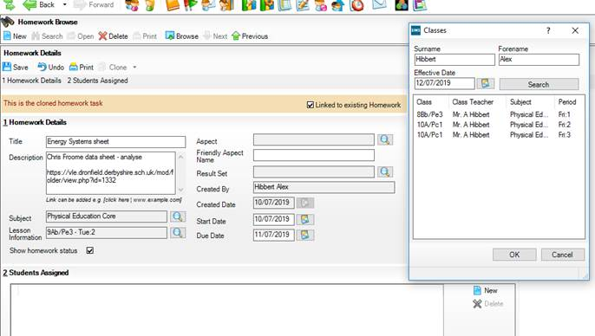

* Clone the homework – **Clone without students** leaves the ‘lesson information’ box blank. **Clone with students** populates it with the previous class. As far as I can tell, either way is fine.
* Click on the **magnifying glass** to the **right of lesson info** and it brings up the box above which says ‘**classes’**. Then **change the date to find the class that you need**.

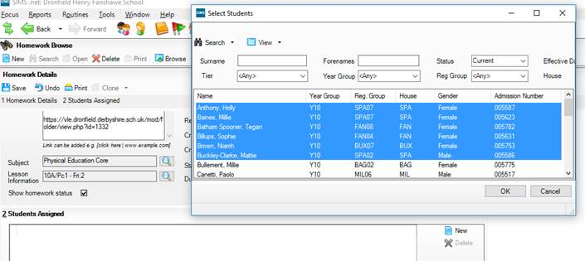

* Then click on ‘**new’** and then this brings up the box above with all of the students in that class. Unfortunately it doesn’t automatically populate the ‘students assigned’ box as would be ideal.
* Hold **Ctrl** and **click** on the students you want to assign (unfortunately for some reason Ctrl+A DOES NOT assign the whole class). When you have clicked on the relevant students, **they turn blue** as above. Click **OK**.

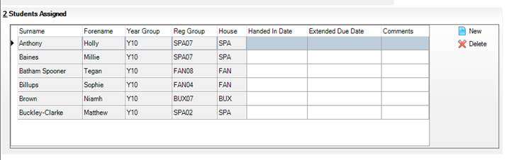

* The students should now appear as ‘**students assigned**’ in the bottom box.
* Save as normal once you have included start and due dates etc.