Student welcome pack

Contents
1. About the course
2. Resources
3. Expectations
4. Staff
5. What to expect in each unit

- About the course
We chose Pearson BTEC Level 3 Applied Science to teach DHFS students because it:
- Contains a broad range of Biology, Chemistry and Physics content.
- Emphasis is placed on learning practical skills that are often required for laboratory roles.
- Practical coursework is assessed using real life scenarios.
- Links scientific theory to relevant practical applications.
- Includes the development of intrapersonal and interpersonal skills.
- Allows student to confidently progress on to higher education or employment in the applied science sector.
Overview
- 360 guided learning hours over 2 years.
- 5 lessons per week.
- Equivalent in size to one A Level.
- Pass (P), Merit (M), Distinction (D), Distinction* (D*)
Course content:
Year 1
- Unit 1 (Principles and applications of science)
- Unit 2 (Practical Scientific Procedures and Techniques)
Year 2
- Unit 3 (Science Investigation Skills)
Unit 8 (Physiology of Human Body Systems)
2. Resources
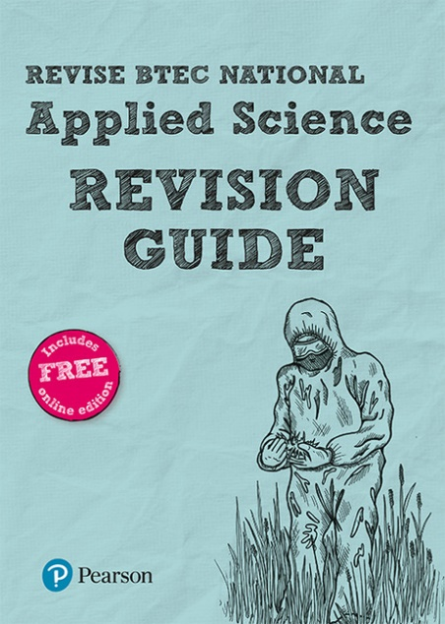

BTEC National Applied Science Revision Guide
Includes module content and revision activities for units 1 and 3.

Price: £11.50

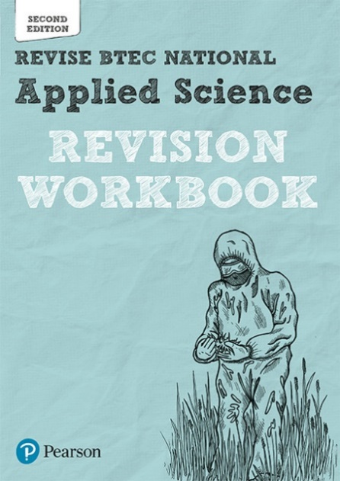
BTEC National Applied Science Revision Workbook
Includes practice questions for units 1 and 3.
Price: £10.99

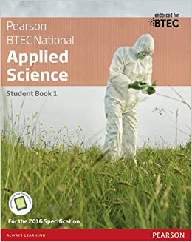

BTEC National Applied Science Student Book 1
Includes module content and worked examples.
Price: £32.28

- Expectations
Equipment:

Every lesson requires:
- Pen, Green Pen, Pencil, Ruler, Eraser, Sharpener, Scientific calculator
- Coloured pens for diagrams
- Periodic table
- Lab book
- Lined paper

Attendance:

Obviously, 100% attendance is our expectation to succeed. Every lesson includes new content that may not be visited again. However, if lessons are missed, you should:
- Contact your teacher via email ASAP, preferably before the lesson.
- Complete tasks set by your teacher for the next lesson
- Use the VLE to locate relevant lesson slides to take notes.

Attitude:

- Commitment. Match the 5 hours a week in lesson with 5 hours of your own independent study, including homework. If you stick to this from the beginning, you will be successful.
- We try to encourage a friendly environment where students are comfortable enough to ask questions, no matter how silly they may think it is. Making mistakes is important for learning!
- Take part in discussions, be inquisitive, challenge ideas!
- Students should expect to be asked questions regularly every lesson. It is important teachers know how much or how little you have learnt. Teachers have a ‘no hands up’ policy.
- Complete all tasks set and aim to complete challenges every lesson.
- Ask for help when needed – please don’t be quiet as this can allow misconceptions to get worse!
- We expect outstanding behaviour from our students. Disruptive and distracting behaviour is not acceptable and will be recorded. If problems persist, the sixth form team will be contacted.

Classwork:
- You must actively take notes during the lesson on lined paper. We recommend writing up these notes again after the lesson for consolidation. If you missed any, ask your teacher to send you the slides.
- When going through work in lesson, green pen must be used to tick, cross and improve work as you go. This is very helpful when you come to revise!

Homework:

- Complete the homework as soon as you get it. Leaving it till the last-minute results in work that does not reflect your true potential and causes missed deadlines.

- Do not rush homework! Try it in enough time so you have an opportunity to ask your teachers before handing it in. ‘I did not get a sheet’ and ‘I lost the sheet’ and ‘can you send me the sheet again’ excuses the night before are particularly irritating.

- If homework is poor quality and you haven’t approached your teacher beforehand, it will be rejected by your teacher unmarked and you will be asked to do it again.

- Teachers will not mark all of your homework. In these cases, they will provide you with mark schemes to DIRT work yourselves.

Folder work:

Both classwork and homework need to be kept organised in order to succeed. Therefore, we expect the following to be put in place. You will not be required to carry your folder around as they will get heavy, however random folder inspections occur twice every year. So, keep it organised from day one!

- Use a ring binder, file dividers, lined paper, a hole punch and plastic wallets
- Have your data sheets and equations at the front of the folder
- Each file divider should be divided into each topic (e.g. Elements of life, Developing fuels, Elements from the sea, Ozone story, What’s in a medicine?, Practical work)
- For each unit, have your specification checklist at the front which is kept up-to-date by completing at the end of each lesson and at the end of the topic
- Complete your own notes during lesson time, giving a clear title using your green pen to tick, correct and improve your work as you go along. It is an expectation you complete DIRT work habitually.
- File certain topics (sub topics) within a module together in a plastic wallet and title this clearly with either a post-it or written in marker on the wallet
- At the end of each module, have a separate wallet for (a) assessments and (b) homework
- You may wish to keep your lab book in your ‘practical work’ section.

Practical work expectations:
Students must complete practical activities during each unit.
Lab book expectations

- Bring your lab book with you every lesson, or store in F1.
- All practical work is dated. This must match the teachers records of when the practical activity was completed.
- All practical work titled correctly.
- Write-up practical work and complete all questions and extension opportunities.
- When marked, DIRT must be completed in green pen in response to teacher feedback.
- It is a good idea to keep it neat and organised.

Expectations before and during practical work

- Risk assessment completed.
- Goggles worn when using chemicals.
- Hair tied back when using Bunsen burners.
- Stool tucked under and stood up at all times.
- Sensible behaviour.
- Equipment is very expensive so extra care is necessary.
- Alert a teacher if glassware has broken or a chemical spillage has occurred. Do not attempt to clean up yourself unless your teacher allows.
- Be responsible for cleaning glassware you have used and putting it back in the appropriate places. The lab must look the way it did when you entered!
- Failure to meet these expectations may result in you having to repeat an experiment in your own time.

4. Staff:
Mr D. Osborne dosborne@dronfield.derbyshire.sch.uk
Miss L. Webster lwebster@dronfield.derbyshire.sch.uk
Students are assigned two teachers over the entire course. There are 5 lessons per week in a 2:3 teacher ratio.
All teachers are available for support and contactable by email (above). They are more than happy to help support your journey through the course!

- What to expect in each unit
Unit 1: principles and applications of science (25% of final grade and 90 learning hours)
Key info:
- Near pass (NP), Pass (P), Merit (M) and Distinction (D)
- External examination worth 90 marks with a total time of 2 hours.
- This is undertaken during one examination session but is split in to 3 x 40 minutes for each of Biology, Chemistry and Physics.
- To be taken in May/June of Y12.
Content:
- Biology: Microscopy, cells, specialised cells, musculoskeletal system, cardiovascular system, gas exchange
- Chemistry: The periodic table, atomic structure, structure and bonding, moles, concentration, physical and chemical properties
- Physics: Properties of waves, waves in communication, electromagnetic spectrum
Assessment:
1 Demonstrate knowledge of scientific facts, terms, definitions and scientific formulae
Command words: give, label, name, state
Marks: ranges from 12 to 18 marks
2 Demonstrate understanding of scientific concepts, procedures, processes and techniques and their application
Command words: calculate, compare, discuss, draw, explain, state, write
Marks: ranges from 39 to 45 marks
3 Analyse, interpret and evaluate scientific information to make judgements and reach conclusions
Command words: calculate, comment, compare, complete, describe, discuss, explain, state
Marks: ranges from 18 to 24 marks
4 Make connections, use and integrate different scientific concepts, procedures, processes or techniques
Command words: comment, compare, complete, discuss, explain
Marks: ranges from 9 to 12 marks

Unit 2: Practical Scientific Procedures and Techniques (25% of final grade and 90 learning hours)
Key info:
- Pass (P), Merit (M) and Distinction (D)
- Internal assessment (coursework)
- 4 assessments (each worth 25% of the unit 2 grade)
Content:
- A Undertake titration and colorimetry to determine the concentration of solutions
- B Undertake calorimetry to study cooling curves
- C Undertake chromatographic techniques to identify components in mixtures
- D Review personal development of scientific skills for laboratory work
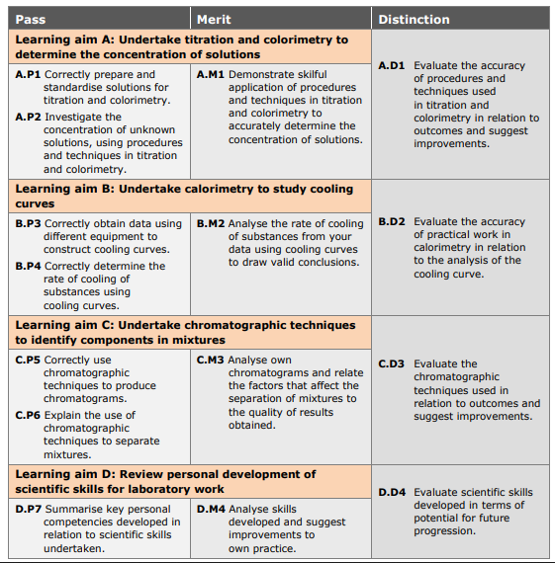
Unit 3: Science Investigation Skills (33.3% of final grade and 120 learning hours)
Key info:
- Pass (P), Merit (M) and Distinction (D)
- Obtain results/observations from a practical investigation (Part A).
- 8 days later, your grade for Unit 3 is assessed through a written examination task (Part B) worth 60 marks.
- Examination is 1 hour 30 minutes.
Content:
- Enzymes
- Diffusion
- Plants
- Energy and fuels
- Electrical circuits

1 Demonstrate knowledge and understanding of scientific concepts, procedures, processes and techniques and their application in a practical investigative context
2 Interpret and analyse qualitative and quantitative scientific information to make reasoned judgements and draw conclusions based on evidence in a practical investigative context
3 Evaluate practical investigative procedures used and their effect on the qualitative and quantitative scientific information obtained to make reasoned judgements
4 Be able to make connections between different scientific concepts, procedures, processes and techniques to make a hypothesis and write a plan for a practical investigation

Unit 8: Physiology of Human Body Systems (16.6% final grade and 60 learning hours)
Key info:
- Near pass (NP), Pass (P), Merit (M) and Distinction (D)
- Internal assessment (coursework)
- 3 assessments
Content:
- Musculoskeletal system
- Musculoskeletal disorders
- Structure and function of the lymphatic system
- Lymphatic disorders
- Digestive system
- Digestive system disorders

