Dronfield Henry
Fanshawe School

Homework Guide

3Rs@DHFS: Responsibility, Resilience and Reflection

Contents

Content

- SIMS Parent App – First Time Users
3. SIMS Parent App – FAQ
4. SIMS Parent App – Homework
5. Accessing SIMS parent app – Visual
6. Accessing SIMS student app – Visual
7. FAQ

SIMS Parent App – First Time Users

The new SIMS Parent App

We have a convenient new way to share information with you about your child’s school life.
You can access the system from a smartphone, tablet or PC - anytime, anywhere.

What you will find in the SIMS app:
- Important information such as attendance data, timetables and achievement data;
- School term, inset dates and contact details.

You will be able to:
- access to your child’s school report;
- Update your contact details so we always have the most up to date information in case of emergency.

Information that you receive through the app will help you to stay up to date with your child’s school life as well as support your child’s development and progress.

The invite email
You will receive an automated email, which is your invite to join SIMS Parent. This contains a link, which you will need to click in order to activate your account. The email address noreply@sims.co.uk is used to send the automated emails. Please add noreply@sims.co.uk to your address book to ensure that emails are not sent to your junk folder. You will no longer have separate login details for the system and instead will use your own email address to access the system. When you initially set up your account you will register for your SIMS Parent account using your own email address and email password.

Activating your account
To register for SIMS Parent you will need one of the following accounts: Microsoft, Office 365, Google, Facebook, Twitter.
- Please click on the link in the email, which will direct you to the Sign in page.
- Please click on one of the options, which is your preferred method to log in to SIMS Parent in future. (Please do not select SIMS ID)
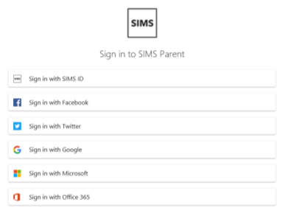

- This will direct you to a different log in screen relevant to the Third Party account that you have selected. Once the new screen is displayed, please enter your existing account details for this provider.
You may need to click on a permission button to allow your SIMS Parent account to attach to your Third Party account

Once you have entered your Third Party account details, this will direct you to the following page:
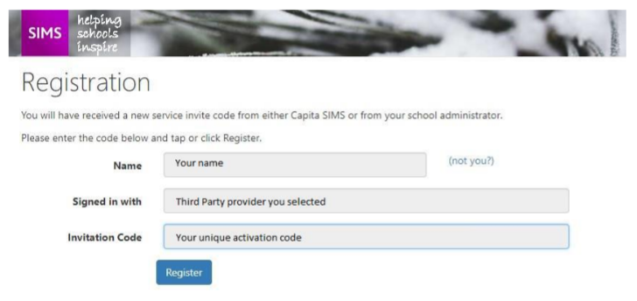

- Please check that your details are correct.
- Click on Register.
- This will ask you a security question e.g. the date of birth of one of your children at the school. This needs to be in the following format dd/mm/yyyy
- Enter one of your children’s date of birth e.g 01/12/2000
- Click on Verify

This will check the system to ensure that this matches our records within our Management Information System. Should this not allow you to access your account, please contact the school. You have now activated your account and will be able to log in to SIMS Parent for the first time.

Logging in to SIMS Parent for the first time
Please log in to your account using your third party log in details to ensure that you are able to access your account. You will then be able to log in to SIMS Parent via the website and/or app in future using the Third Party account details you have entered.
Please note:
Your account allows you to access each of your children at Dronfield Henry Fanshawe School. When you complete this process, you will need to use the same Third Party provider / method of logging in to SIMS Parent in future. As you use a Third Party account to access SIMS Parent, the school are unable to help you with your username and password. However, if you are unable to access your account entirely, please contact the school and we will assist you. Your activation email, which you receive from noreply@sims.co.uk is unique to you and should not be used by anyone else. If you require an additional login then please contact the school to request the additional account. Once the registration is complete then do not use the link in the activation email again. The link in your activation email will expire after 3 months if it is not used, please contact the school if you require a further activation email if your previous one has expired.

Sharing your password
Your username and password should never be disclosed to anyone. Passwords and user names should never be shared except between those with parenting responsibility.

Queries relating to SIMS Parent
If you have any queries relating to SIMS Parent, please contact the school, at the email address parentapp@dronfield.derbyshire.sch.uk.

SIMS Parent App– FAQ(General)

- I received the initial introductory email but haven’t yet received my activation email?
If you haven’t yet received your activation email then send a message to
parentapp@dronfield.derbyshire.sch.uk. After some security checks, you will receive
your activation email within 2 working days.

- I haven’t received a username and password?
Unlike ePortal our previous system, you are not sent any login credentials. By clicking on the
activation email this then takes you to a screen that allows you to associate a login type you may
already possess with ParentApp. This will then save you having to remember an extra set of logon
details for ParentApp.

- I don’t have one of the logon types it suggests. How do I logon?
Unfortunately you will need one of the following logon types.
- Facebook
- Google
- Microsoft
- Twitter
- Office 365
If you don’t have one they are free to setup.

- It has a SIMS ID logon in the list. Can’t I be sent one of these?
Unfortunately SIMS ID is only available to users at Dronfield Henry Fanshawe School. It is not
available to other users of SIMS (other schools) or to Parents.

- The system doesn’t logon properly and I see a blank screen or a message saying that I am unauthorised?
Once you have used the activation link within the email we sent you then do NOT use that link again.
The activation link should only be used once. After that we advise that you access ParentApp via our
website. This is done by clicking on the PORTAL button, choosing ParentApp and clicking GO.

- The system tells me that the activation code has failed. What do I do?
If you email the school on parentapp@dronfield.derbyshire.sch.uk then we will send you a new
activation code within 2 working days.

- I logon OK but one of my children isn’t displayed?
We have had a few instances where a tick box in the ParentApp system has not been applied
correctly for certain parents. If you email parentapp@dronfield.derbyshire.sch.uk then we will
resolve this within 2 working days and the missing child will automatically appear.

- Some of the personal details are wrong within the system. How do we correct this?
The ParentApp system allows you to send changes in via the App. If that doesn’t work then you can
contact the school directly. We do encourage all parents to keep their information up to date and
especially your contact details.

- I’ve spoken to friends and they have received the introductory letter and activation but I haven’t. Why is this?
This can happen for a couple of reasons.
ParentApp is only sent to priority parents/carers. We will not send ParentApp details to contacts
who are not assigned parental responsibility.
The email address details we have on the system might have changed and we have not received up
to date contact details for you.

- Isn’t using social media logons to link to our children’s personal data unsafe?
The security of all personal data is of the utmost importance to the school.
The systems only share elements of the credentials but no more. The ParentApp system identifies
the user, checks with the third party to ensure the credentials are correct and then passes control
back to ParentApp. None of the data in ParentApp is seen by the Social Media account. Even if a
third party provider was hacked then there is no direct link into your child’s data and no way for the
hacker to know that ParentApp even exists for that user.

SIMS Parent App - Homework

From the 24th June 2019 DHFS will be switching to SIMS for the access, recording and monitoring of homework. This means students will no longer use their planner as a main way to record their homework. Homework will be accessed by students and parents using the SIMS log on. At this point all parties will be able to see:

- The homework subject and teacher
- Detail of the homework
- The due date
- When your child handed in the homework
- Any teacher comments regarding the homework completed

Students planners will still be an integral part of the school day and can be used by students as we make the homework transition. Students are able to access computers at school and details of times and areas can be seen below:

Accessing SIMS through computers:

 | LRC | ELC | A7 | Dronfield Library
Monday | 8.30am-4.00pm (KS5 4.30pm)  Closed at lunch | 12.30pm-1.15pm | 8.00am – 5.00pm | 9.00am – 7.00pm
Tuesday | 8.30am-4.00pm (KS5 4.30pm) | (KS5 4.30pm) | 8.00am – 5.00pm | 9.00am – 7.00pm
Wednesday | 8.30am-4.00pm (KS5 4.30pm) | (KS5 4.30pm) | 8.00am – 5.00pm | 9.00am – 5.00pm
Thursday | 8.30am-4.00pm (KS5 4.30pm) | (KS5 4.30pm) | 8.00am – 5.00pm | 9.00am – 5.00pm
Friday | 8.30am-3.30pm | (KS5 4.30pm) | 8.00am – 5.00pm | 9.00am – 7.00pm
Saturday | - | - | - | 9.00am – 4.00pm

Accessing SIMS Parent App

After following the log on process, parents/carers will be able to access the SIMS Parent App through two different ways:
- The school website
- Through downloading the SIMS Parent App to an electronic device.

The School Website

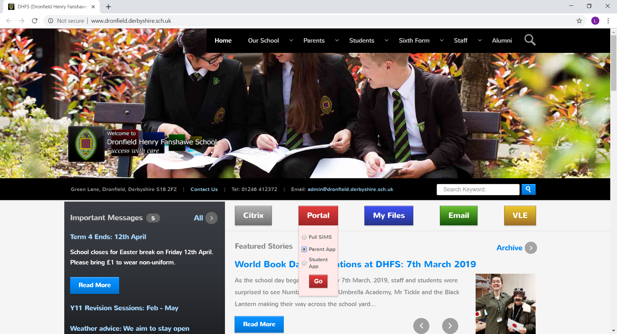
- Go to DHFS website
- By clicking on Portal
- Select Parent App
- Use SIMS log on details.

SIMS Parent App

By downloading the SIMS Parent App on your devices store (free):

Parents will now be able to see the homework area:
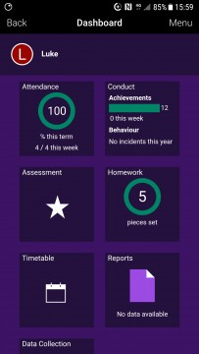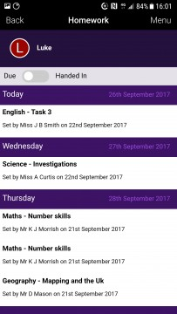
- Parents can clearly see homework which is due or has been handed in and the detail behind each.

- Parents can clearly see the amount of homework set a child has been allocated

Accessing SIMS Student App

After following the log on process, students will be able to access the SIMS Parent App through two different ways:
- The school website
- Through downloading the SIMS Student App to an electronic device.

The School Website
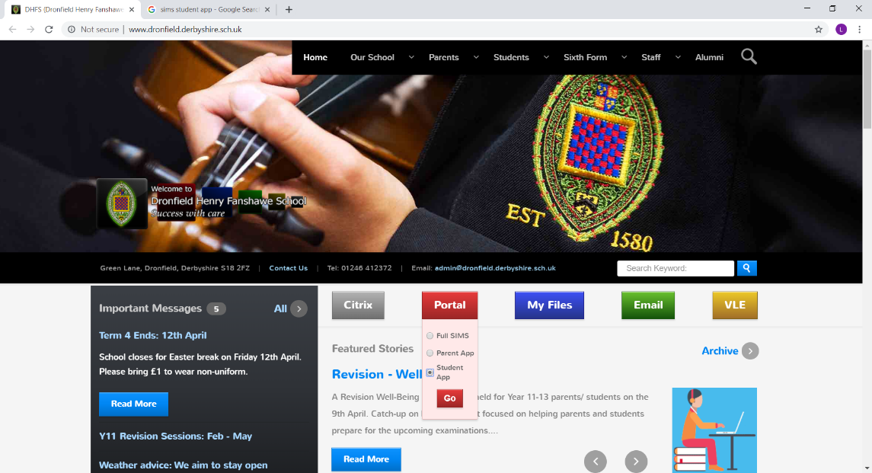

- Go to DHFS website
- By clicking on Portal
- Select Student App
- Use SIMS log on details.

SIMS Student App

By downloading the SIMS Student App on your devices store (free):

Accessing homework attachments

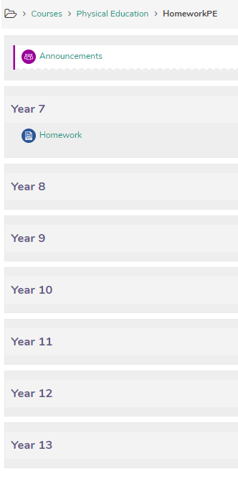
Within some homework staff may need to direct students to additional resources or attachments. These can be found in our VLE which house resources in every subject.

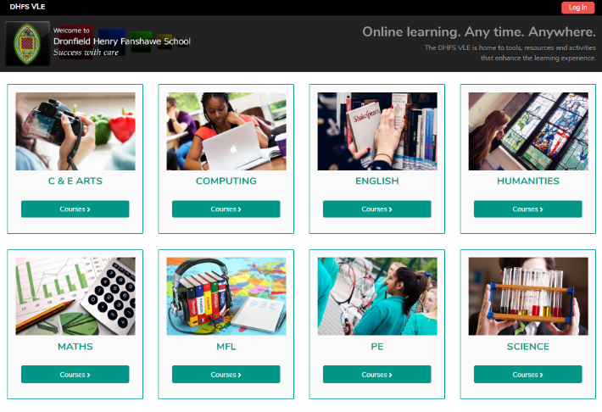
Staff will direct students to the VLE on the main areas for homework.

FAQ

- My child does not always have access to an electronic device or phone to look at their homework
Students will be able to access their homework on our school computers through a variety of ways.

Learning Resource Centre | Monday-Thursday 8.30am – 4.00pm (KS3-4), 8.30am-4.30pm (KS5)  Friday 8.30am – 3.30pm  Closed Monday lunchtime
Electronic Resources Centre | 12.30pm-1.15pm (last entry 1pm)
A7 Classroom | 8.00am- 8.50am / 3.30pm – 5.00pm
Dronfield Library | Monday: 9am - 7pm  Tuesday: 9am - 7pm  Wednesday: 9am - 5pm  Thursday: 9am - 5pm  Friday: 9am - 7pm  Saturday: 9am - 4pm  Sunday: Closed  Free internet access –13 computers, printing 10p/sheet. Computers can be reserved for 1 hour sessions.  Study space –two seating areas, 4 students each. Quiet study room, 6 students.  Scanner, free to use.  Photocopier 10p/sheet (B/W), £1/sheet (colour)

- What if my child has trouble with accessing the homework?
Just like another homework issues we aim to embed responsibility within our student. If students do find issues with the system, have trouble with the homework set or any other concerns it is their responsibility to speak to the teacher to resolve these issues.

- What will happen to the planner?
During 2019/2020 all DHFS students will still be allocated a planner to ensure this smooth transition.

- What about attachments
On occasion staff may wish for students to access attachments such as resource sheets or additional sheets. This will be outlined in the initial homework set and all attachments will be accessible through the VLE (please see detail above)

- What can I do as a parent?
The SIMS homework access allows for a stronger link between school and home allowing parents to feel part of their child’s learning. Parents may chose to monitor from afar or keep a closer interest in their child’s homework progress.

- Will students be able to use their devices in school?
Students will still not be able to access their mobile phones within school unless direct to by the teacher. School has plenty of areas students can use to access their homework and initially homework is for home.

