Year 12, 10 mark trial exam question

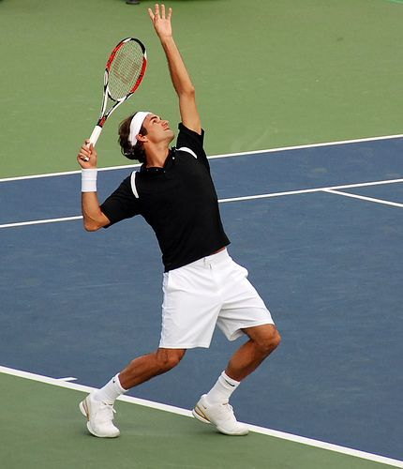

1, Apply Newtons laws to the tennis serve above?

2, Discuss the potential injuries associated with this activity and suggest the possible treatments available?
If possible, please word process your answer and send back to the relevant member of staff.

