Psychology – Social Influence (Section A)
30 minutes
Email to Mrs Ellis
Please delete lines and type your answers in a different colour or send clear pictures of hand written answers with the question clearly identified.

1) Outline the authoritarian personality as an explanation for obedience. [4 marks]
___________________________________________________________________________________________________________________________________________________________________________________________________________________________________________________________________________________________________________________________________________________________________________________________________________________________________________________________________________________________

2) Briefly explain one limitation of the authoritarian personality as an explanation of obedience. [2 marks]
_____________________________________________________________________________________________________________________________________________________________________________________________________________________________________________________________________________________________

3) Outline and discuss how consistency and commitment might contribute to minority influence. [8 marks] ____________________________________________________________________________________________________________________________________________________________________________________________________________________________________________________________________________________________________________________________________________________________________________________________ __________________________________________________________________________________________________________________________________________________________________________________________________________________________________________________________________________________________________________________________________________________________________________________________________________________________________________________________________________________________________________________________________________________________________________________________________________________________________________________________________________________________________________________________________________________________________________________________________________________________________________________________________________________________________________________________________________________________________________________________________________________________________________________________________________________________________________________________________________________________________________________

4) A researcher carried out a study based on Asch’s research to see if task difficulty box affects conformity. Easy task condition: the standard line was very different from the incorrect comparison lines. Difficult task condition: the standard line was very similar to the incorrect comparison lines. Participants took part in only one condition and were not matched. They were asked to state which comparison line was the same as the standard line. In both conditions, four confederates (people working with the researcher) gave the same wrong answer. The researcher recorded whether each participant did or did not conform.

4.1) Write a suitable directional hypothesis for this study. [3 marks]

___________________________________________________________________________________________________________________________________________________________________________________________________________________________________________________________________________________________

4.2) Identify the experimental design used in this study. Explain one advantage of using this design in this study [3 marks)
_____________________________________________________________________________________________________________________________________________________________________________________________________________________________________________________________________________________________

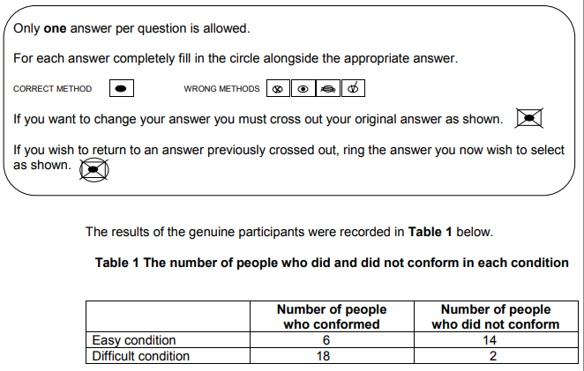

4.3) Refer to the data in Table 1. Which of A, B, C or D is the correct ratio of participants who conformed in the easy condition to those who conformed in the difficult condition? Shade one box only. [1 mark]
- 1:2
- 1:3
- 1:4
- 3:1

4.4) Refer to the data in Table 1. Which of A, B, C or D is the correct percentage of participants who did not conform in the study? Shade one box only. [1 mark]
A) 5%
B) 35%
C) 40%
D) 87.5%

4.5) Using your knowledge of social influence, explain the difference in conformity between the two conditions. [2marks]
____________________________________________________________________________________________________________________________________________________________________________________________________________________________________________________________________________________________________________________________________________________________________________________________

Total = 24 marks

--------------------------------------------------------END OF SECTION A--------------------------------------------------------------------

