Questions
Q1.
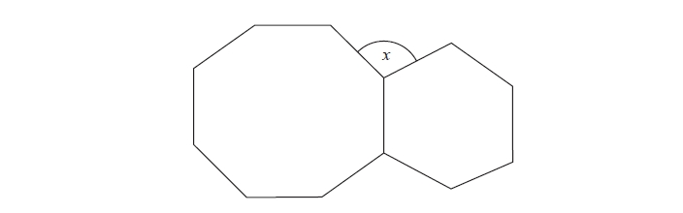
The diagram shows a regular octagon and a regular hexagon.
Find the size of the angle marked x
You must show all your working.
x =........................................................... º

(Total for question = 3 marks)

Q2.
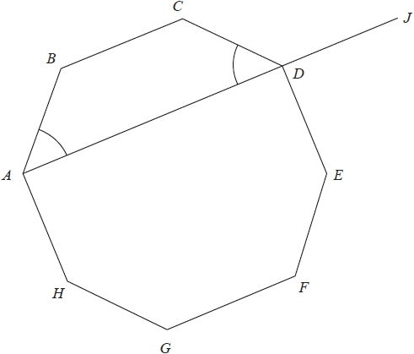
ABCDEFGH is a regular octagon.
ADJ is a straight line.
angle BAD = angle CDA
Show that angle CDJ = 135°
(Total for question = 4 marks)

Q3.
ABCDE is a pentagon.
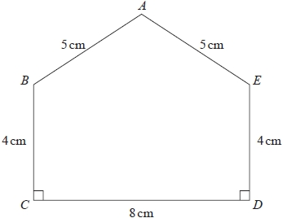
Work out the area of ABCDE.
........................................................... cm²

(Total for question = 5 marks)

Q4.
Triangles ABD and BCD are right-angled triangles.
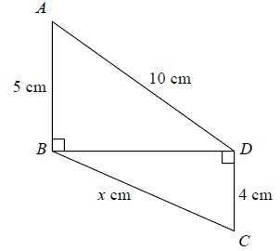
Work out the value of x.
Give your answer correct to 2 decimal places.
...........................................................
(Total for question = 4 marks)

Q5.
ABCD is a trapezium.
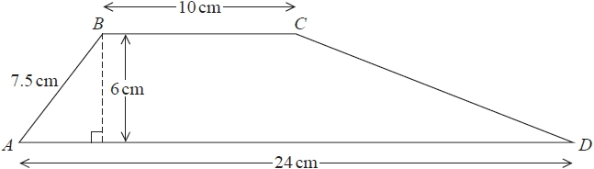
Work out the size of angle CDA.
Give your answer correct to 1 decimal place.
........................................................... °

(Total for question = 5 marks)
Q6.
ABC is a right-angled triangle.
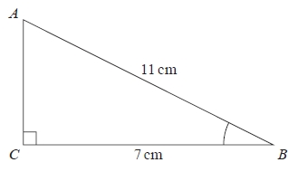
(a) Work out the size of angle ABC.
Give your answer correct to 1 decimal place.
........................................................... °
(2)
The length of the side AB is reduced by 1 cm.
The length of the side BC is still 7 cm.
Angle ACB is still 90°
(b) Will the value of cos ABC increase or decrease?
You must give a reason for your answer.
.............................................................................................................................................
.............................................................................................................................................
(1)
(Total for question = 3 marks)
Q7.
Write these numbers in order of size.
Start with the smallest number.
2.5 × 10² 0.0025 2.5 × 10⁻² 2500
.............................................................................................................................................

(Total for question = 2 marks)

Q8.
(a) Write 2.673 × 10⁴ as an ordinary number.
...........................................................
(1)
(b) Write 0.0704 in standard form.
...........................................................
(1)
(c) Calculate (4.515 × 10⁶) ÷ (3.01 × 10⁻²)
Give your answer in standard form.
...........................................................
(2)

(Total for question = 4 marks)

