Year 12 Assessment Week – History – India, c1914-48: the road to independence
1a) Add 3 events in chronological order that create a link from the two events below. (3 marks)
1857 – Indian Mutiny
__________________
__________________
__________________
13th April 1919 – Amritsar Massacre
1b) For each event explain how they explicitly link to the Indian Mutiny, Massacre or another event on your list.
Event 1 - __________________________________________________________________________ _______________________________________________________________________________________________________________________________________________________________________________________________________________________________________________ 2 marks
Event 2 - __________________________________________________________________________ _______________________________________________________________________________________________________________________________________________________________________________________________________________________________________________ 2 marks
Event 3 - __________________________________________________________________________ _______________________________________________________________________________________________________________________________________________________________________________________________________________________________________________ 2 marks
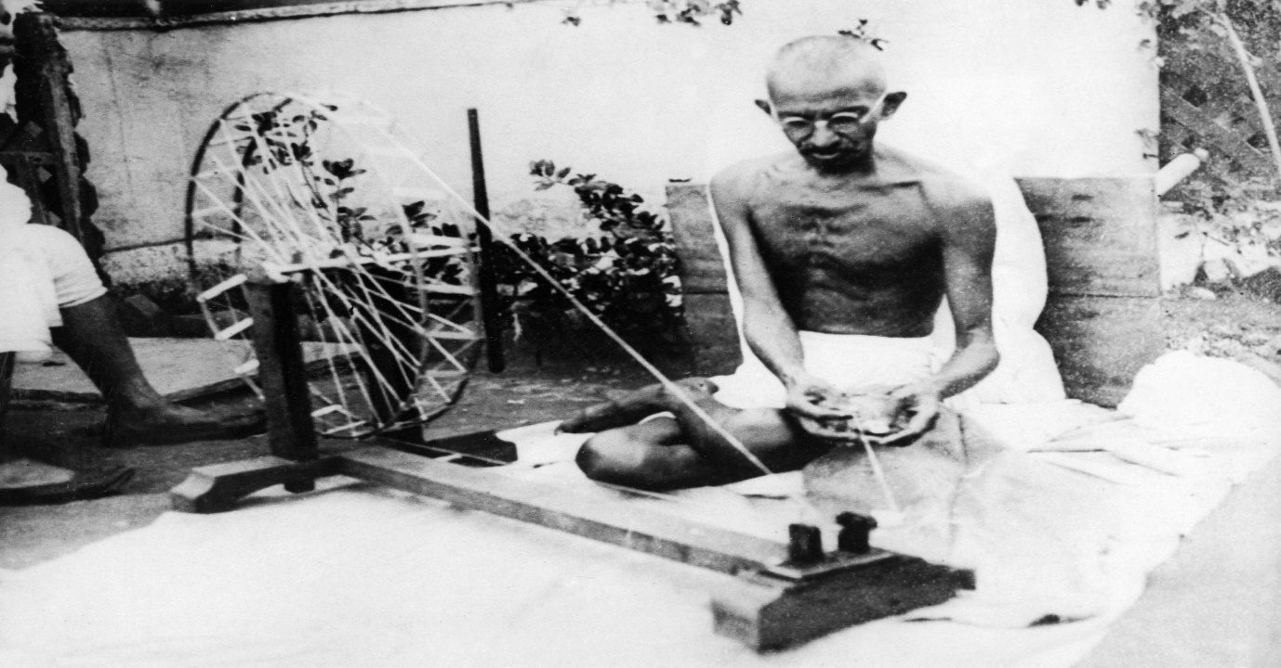
2) Study the source below and answer the following questions:
A photograph, taken in 1925, of Gandhi spinning cotton thread at Sabarmati Ashram, in Ahmedabad.
a) Explain why Gandhi spinning is a form of protest. (2 marks)
__________________________________________________________________________________________________________________________________________________________________________________________________________________________________________________________________________________________________________________________________________________________________________________________________________________________
b) Explain another form of protest Gandhi used in this time period. (2 marks)
__________________________________________________________________________________________________________________________________________________________________________________________________________________________________________________________________________________________________________________________________________________________________________________________________________________________
c) Give a specific example of another protestor who would have disagreed with Gandhi’s methods and why. (2 marks)
__________________________________________________________________________________________________________________________________________________________________________________________________________________________________________________________________________________________________________________________________________________________________________________________________________________________

3a) Below are two accounts of the success of the Roundtable Conferences. Use your source analysis skills to fill in the boxes and reach a judgement on the overall utility of both accounts. (8 marks)
Source 5 - From F. Moraes, Witness to an Era, published in 1973. Moraes was a lawyer and a European educated Indian who also worked as a journalist and newspaper editor. He reported on the second Round Table Conference.

Gandhi made a fatal error of claiming to speak for the Muslims and depressed classes. The spokesman of both communities repudiated him, and since the Muslims then numbered nearly thirty per cent of the population and the depressed classes about twenty per cent, it was difficult for him to sustain his claim that he represented ninety-five per cent of India. Gandhi had, in fact, come to a tentative agreement with the Muslims on the basis of joint electorates for Hindus and Muslims, but when it came to an apportionment of seats between Hindus, Muslims and Sikhs, he yielded to the extremist Hindu leader, Pandit Madan Mohan Malaviya, who insisted that the only seat in dispute should go to the Sikhs and not to the Muslims. That Gandhi’s efforts at a Muslim-Hindu settlement should have failed was bad enough. That they failed over the allocation of one seat made the attempt ridiculous. The minorities, comprising the Muslims, depressed classes, a section of Indian Christians, the Anglo-Indians and the British community then confronted the British government with a document embodying an agreement arrived at between themselves. Whitehall had no alternative but to announce that the government would make its own award.

Evidence to show the source’s provenance (NOP) is useful: | Evidence to show the source’s content is useful:
Evidence from your own knowledge to support: | Evidence from the source or your own knowledge that challenges it’s usefulness:

Source 7 – Part of a letter written by M. R. Jayakar in January 1942. Jayakar was a liberal Hindu politician who attended the second Round Table Conference.

Jinnah’s attitude at the Round Table Conference surprised everyone, including the British Delegation. His one effort was, and a deceitful one too, to accept all the concessions that were made to him on behalf of the Hindus and subsequently to take them privately to the Prime Minister, Ramsay MacDonald, and to say to him in a bargaining spirit: ‘This is what the Hindus are prepared to give; how much more will the British government give the Muslims?’ This method of bargaining became in course of time so notorious that ultimately MacDonald telephoned me, asking me to stop this process of bargaining, for it was most deceitful and led nowhere. I am citing this incident as proving the unscrupulous way in which Jinnah will bargain for the Muslim cause. As you are dealing with him, I have to warn you to be very careful.

Evidence to show the source’s provenance (NOP) is useful: | Evidence to show the source’s content is useful:
Evidence from your own knowledge to support: | Evidence from the source or your own knowledge that challenges it’s usefulness:

b) Which source do you believe holds more weight for a study into the failure of the Roundtable Conferences? Explain your justification. (4 marks)
____________________________________________________________________________________________________________________________________________________________________________________________________________________________________________________________________________________________________________________________________________________________________________________________________________________________________________________________________________________________________________
c) What source could be used to strengthen our understanding of the Roundtable Conferences? (2 marks)
________________________________________________________________________________________________________________________________________________________________________________________________________________________________________________________________________________________________________________________________________
4a) For each statement mark how far you agree and explain your opinion.
1) Communal violence in 1947 was inevitable.
Disagree 1 2 3 4 5 6 7 8 9 10 Agree
Why? _____________________________________________________________________________ ________________________________________________________________________________________________________________________________________________________________________________________________________________________________________________________________________________________________________________________________(3 marks)

2) Jinnah always wanted the creation of Pakistan after partition.
Disagree 1 2 3 4 5 6 7 8 9 10 Agree
Why? _____________________________________________________________________________ ________________________________________________________________________________________________________________________________________________________________________________________________________________________________________________________________________________________________________________________________ (3 marks)

3) Post-Partition India was no different to India under the Raj.
Disagree 1 2 3 4 5 6 7 8 9 10 Agree
Why? _____________________________________________________________________________ ________________________________________________________________________________________________________________________________________________________________________________________________________________________________________________________________________________________________________________________________ (3 marks)
4b) For one of the statements give two specific pieces of evidence to support your argument and one to contradict it. (8 marks)
Statement number: ______
Supporting evidence 1 - ______________________________________________________________ ________________________________________________________________________________________________________________________________________________________________________________________________________________________________________________________________________________________________________________________________________
Supporting evidence 2 - ______________________________________________________________ ________________________________________________________________________________________________________________________________________________________________________________________________________________________________________________________________________________________________________________________________________
Counter-argument evidence 1 - ________________________________________________________ ________________________________________________________________________________________________________________________________________________________________________________________________________________________________________________________________________________________________________________________________________
Extra evidence (Support or Counter) - ___________________________________________________ ________________________________________________________________________________________________________________________________________________________________________________________________________________________________________________________________________________________________________________________________________

Total - /48

