For use with section B – Questions 4 (A) & (B)

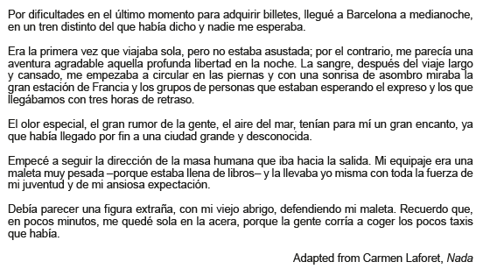

For use with section B – Questions 5

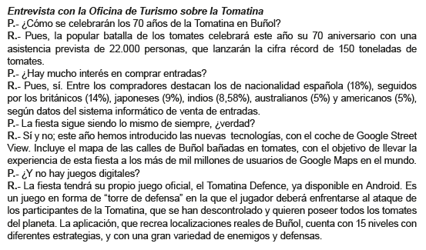

For use with section B – Questions 6 (A) & (B)

