
CRIMINOLOGY SUMMER WORK

Defined end point:
      - By completing the summer work, you will be introduced to representation of crime in different types of media, campaigns for change and theories of criminality. This will help to prepare you for the controlled assessment and exam in Y12.
- Your teachers will look at the summer work to gauge your level of commitment to A-Level study as well as your level of written communication, so ensure it reflects your best and you have invested time and effort into it.

 | Excellent level of effort and understanding | Good level of effort and understanding | Level of effort and understanding requires improvement | Inadequate level of effort and understanding
Describe representation of crime in the media
Comparing campaigns for change
Biological theories of criminality
Sociological theories of criminality
Individualistic theories of criminality
Teacher comment
What to work on moving forward:

Unit 1 AC 2.1 Comparing Campaigns for Change
As part of Unit 1 in criminology you will be learning about campaigns for change. People may campaign for change for various reasons. For some, a campaign for change may be about ‘righting a wrong’ or addressing a social injustice. For others, their own personal suffering may motivate them to campaign for change so that others do not have to face similar experiences.
A campaign may seek to make a formal change, such as a change in law or policy like the campaign which banned smoking in public places in 2006. Such campaigns often begin as campaigns to change attitudes.

Other campaigns may simply want to raise awareness of a particular issue. An example of this would be the Movember campaign, which seeks to raise awareness of men’s health issues, such as testicular cancer, prostate cancer, and male suicide.
As part of your controlled assessment in Year 12 criminology, you will be comparing a number of campaigns for change. Your comparisons will focus on:
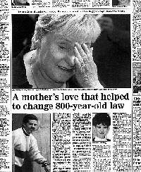
- the aims of the campaign,
- driving forces behind the campaign
- the methods used in the campaign
- public figures involved in the campaign
- the success of the campaign.
One of the campaigns you will be comparing with others is the Ann Ming double jeopardy campaign.
Task – Research Ann Ming’s double jeopardy campaign
What happened to Julie Hogg?
What was the aim of the campaign?
Who were the driving forces behind the campaign?
What methods did Ann Ming use?
Was the campaign successful? Why/why not?
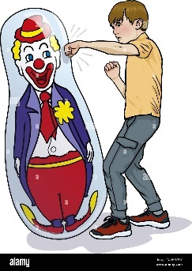
Unit 2 AC 2.1 Theories of Criminality
There are many different explanations for why people commit crime, some argue that people are born criminal, while others argue that we learn criminal behaviour from those around us.
As part of Unit 2, you will be exploring the different theories of criminality from a biological, psychological (individualist) and sociological perspective. You will need to be able to describe the different theories of criminality and evaluate their effectiveness in explaining crime.
Task – Choose one theory from each column in the below table to research. Create an A4 poster for each theory including a description of how the theory explains crime and evaluation of the theory (2 strengths and 2 weaknesses).

Biological | Individualistic | Sociological
- Physiological theories  Lombroso’s atavistic theory  Sheldon’s somatotype theory  - Genetic theories  Jacob’s XYY theory  Twin and adoption studies  - Brain injuries and disorders  - Biochemical theories | - Learning theories  Operant learning theory  Social learning theory  Sutherland’s differential association theory  - Psychodynamic theories  Freud’s psychoanalysis theory  Bowlby’s maternal deprivation theory  - Eysenck’s personality theory  - Cognitive theories  Criminal personality theory  Kohlberg’s moral development theory | - Functionalist theories  Durkheim  Merton’s strain theory  Subcultural theories  - Interactionism  Labelling theory  - Marxist theory  - Left Realism  - Right Realism

Unit 1 AC1.4 The media portrayal of crime
Unit 1 involves looking at different types of media and seeing how crime is shown in those media forms. From this you also consider the impact the media has on people’s perceptions of crime. You need to carry out the tasks and complete the in the boxes below:
Watch a fictional TV programme which features crime being committed (eg Line of Duty, Law and Order, Prison Break, CSI etc). What type of crime in shown? How does the suspect and victim get portrayed? How are investigators shown? Where is the show set?

Watch a factual TV show featuring crime (eg 24 Hours on Police Custody, Forensics CSI). How is crime shown here? Consider the type of crime shown, the portrayal of the victim, suspect, offender, investigators and the setting.

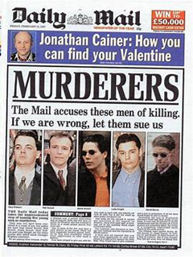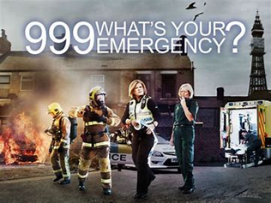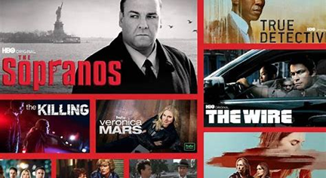
Pick a tabloid newspaper (The Sun, The Daily Mail, The Mirror) and find an article on crime in that paper. Summarise the article first. Then find the same case in a broadsheet newspaper (The Independent, The Guardian). Is the case reported on in the same way or are there differences in how the crime is presented to the reader? You can do this online rather than buying the newspapers.

